

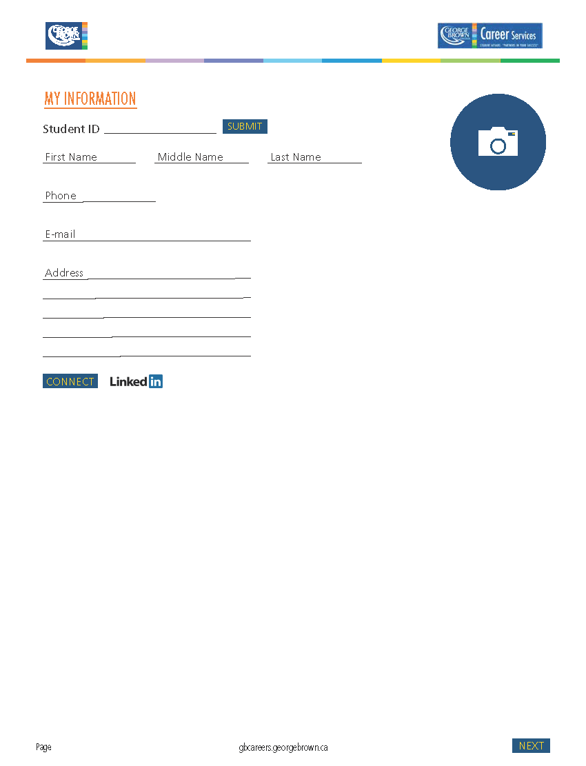

Toronto, ON M9V 4K8

200 King Street East

dmcintyr@georgebrown.ca

416 415-5000 ext. 2326

McIntyre

Diana

3236

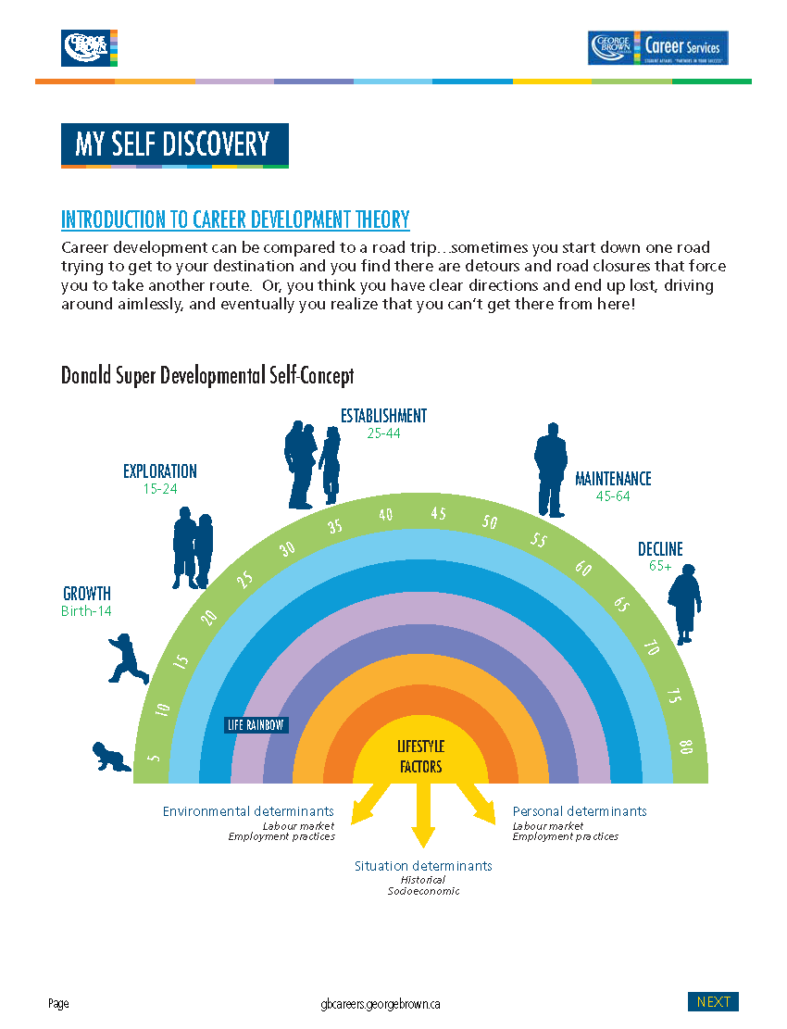

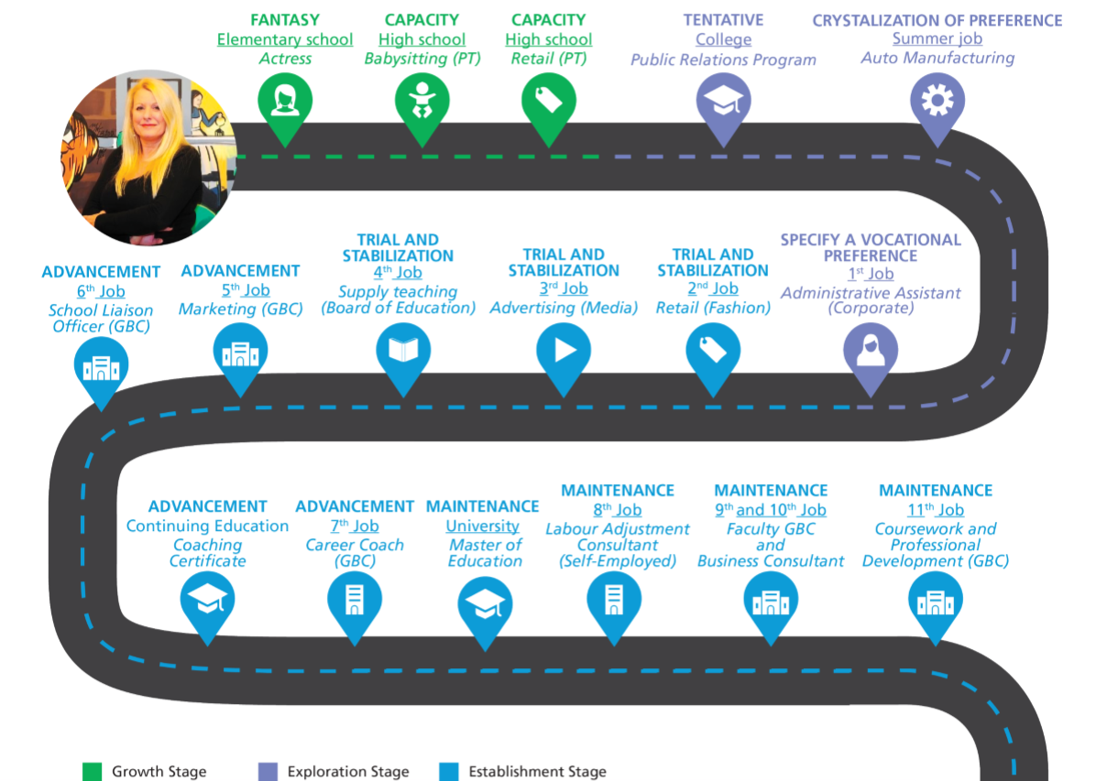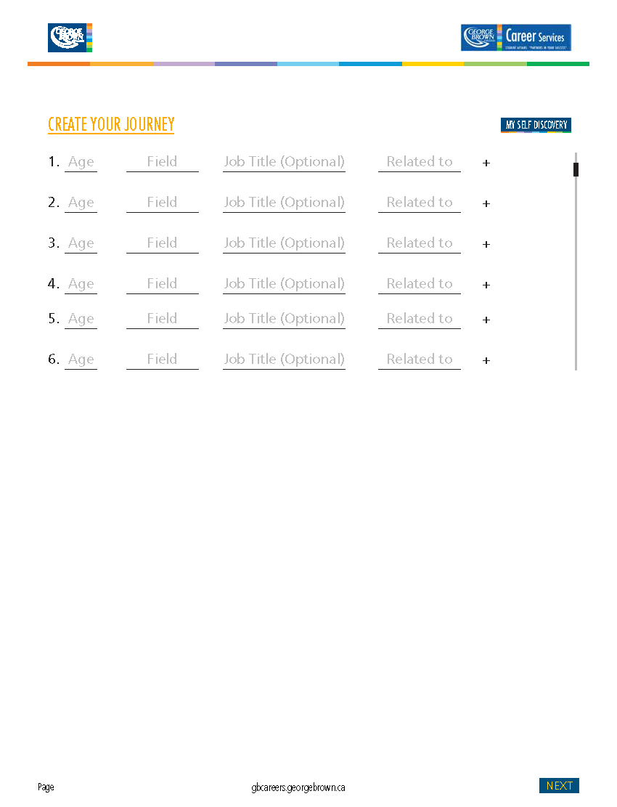

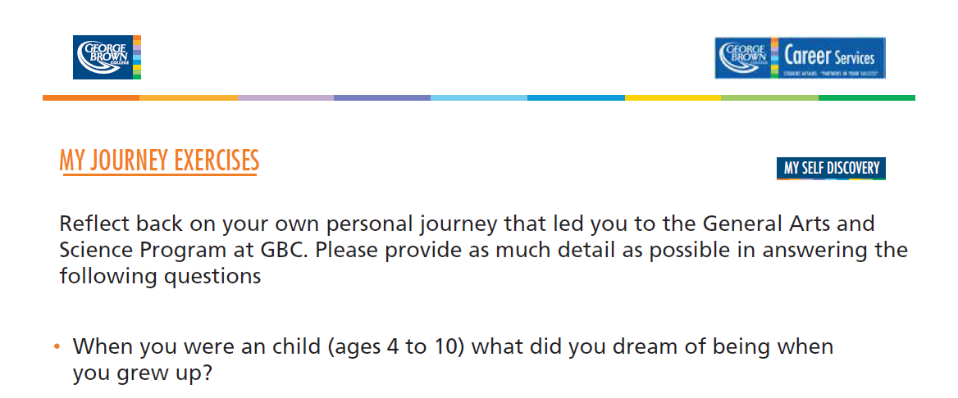

When I was a child (ages 4 to 10), my dream was to entertain people. I had no idea specifically what I wanted to be but I knew I love to talk and perform in front of audiences – which was often my poor family. I would make up songs and sing them to my family after dinners. Often, I would have them sit in our living room so that I could read them a story I had written or perform a skit that I had prepared which always had me as the main actress! What I remember is always wanting to capture people’s attention – I wanted to make them laugh – I wanted them to be curious – and most of all, I wanted them to be entertained.



I was drawn to entertaining people because I loved to be the centre of attention. If I could capture someone’s attention, engage them, or even perhaps inspire them...I was in my element. I was drawn to drama classes at a very young age and always put up my hand to volunteer for the lead role. Where other children were terrified of standing up in front of audiences, I excelled. The bigger the group, the more comfortable I was.



At this age, I cannot say that I had one particular “dream job”. I was always drawn to people who had roles where they could stand up in front of people and make an impression, or change an attitude. My parents really encouraged us to go through life as our authentic selves and focused on our strengths and not our weaknesses. I believe that this helped build my confidence at a very young age and I felt there was nothing that I could not achieve. I was also brought up not to be afraid of failure but rather to embrace it and learn from it.



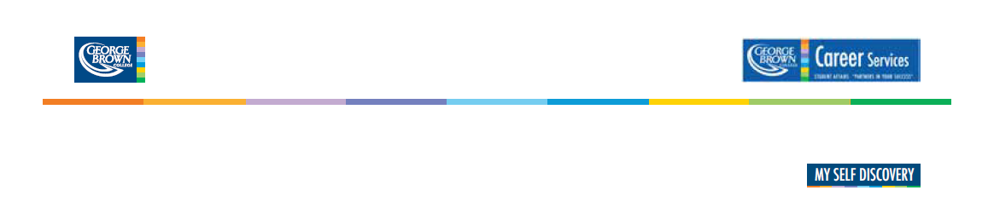



When I was in elementary school (ages 11 to 14), I had a lot of energy and was diagnosed as being attention deficit and hyperactive. At this time, ADHD was not something that was understood and it got me into a lot of trouble in school as no teacher wanted me in their class because I was too disruptive. I had a very difficult time focusing on academics and my main focus was on the social element of school – hanging out with my friends. I was also very competitive and played on a lot of school sports leagues including soccer, baseball, tennis and the running club.



Activities that I found challenging when I was in this age group was sitting still and being quiet. I am a kinesthetic and auditory learner which means that I need to be engaged in activities that enabled me to talk and do. I also really struggled with math. I come from a family of mathematicians and I could never really get the concepts of advanced math (calculus, algebra), nor could I understand why I needed to know this as I would never use it in my life. As a result of this, I became disinterested and decided it was not something I really needed to know.



I feel that at this particular juncture in my life, I really did not know where my interests and skills would lead me. At the time, I did not realize that having really strong social and communication skills would open the door to many different kinds of jobs. In secondary school, my favorite subjects were the ones that came easily to me. I loved theatre arts, music, history, geography, social studies, English, and gym. I was a very mediocre student, as academics were still secondary to my social life – my main priority was still friends and sports. The time I was happiest at school was when I was hanging out with my friends. I viewed classes as just a space to be connected to them and maybe a little learning happened along the way!







I had numerous part-time jobs when I was in high school including babysitting and retail. I enjoyed babysitting, not because I particularly liked children but because it allowed me a lot of autonomy and I was able to create games that the kids could play. Reflecting back, it was the autonomy and creative that I enjoyed not so much the overseeing of children. My experience in retail made me quickly realize that I really don’t like selling to people. You would stand around for long periods of time trying to encourage anyone who entered the store to buy something – whether they needed it or not. I also did not enjoy the aspect of having to hit monthly sales targets. I realized the pressure of selling was not something I enjoyed even though I was good at it.



When I was thinking about post-secondary programs, I was rather limited to my choices. I did not have the grades to get into university and because I had dropped all science and math courses, it was challenging to find a suitable college program. Who would have thought that you need science to get into a psychology program! In my final year of high school, the pressure was on because I had no idea of what I wanted to do. In addition to this, my parents had basically read me the riot act – if I did not take school seriously this time around…they would not support me and I would have to get a job. This terrified me!



I choose a 2-year diploma in public relations because it was one of the few programs I could get into at Durham College and the course description from the calendar sounded somewhat interesting. What I discovered in my first year of college was that the course description is often very different from the course itself. I had a co-op in my 3rd semester and this really nailed the fact that I had no desire to work in public relations. I graduated from college and still had no idea what I wanted to do with my life. Furthering my education sounded like the best option because I was very comfortable hiding in the education system and had no desire to go to work. As my marks were still too low to get into university, I applied as a mature student and was accepted by Trent University in the Bachelor of Arts program. After completing my 3-year BA in Political Science (exactly, what do you do with a political science degree!), I started applying for different types of jobs. Based on the fact that my degree was very general in nature, most of the jobs that I qualified for were in the service sector. For the next three years, I moved around a lot, testing out different types of careers including office administration and retail. I finally ended up, getting a position in the Marketing Department at GBC and a new and exciting chapter in my life began



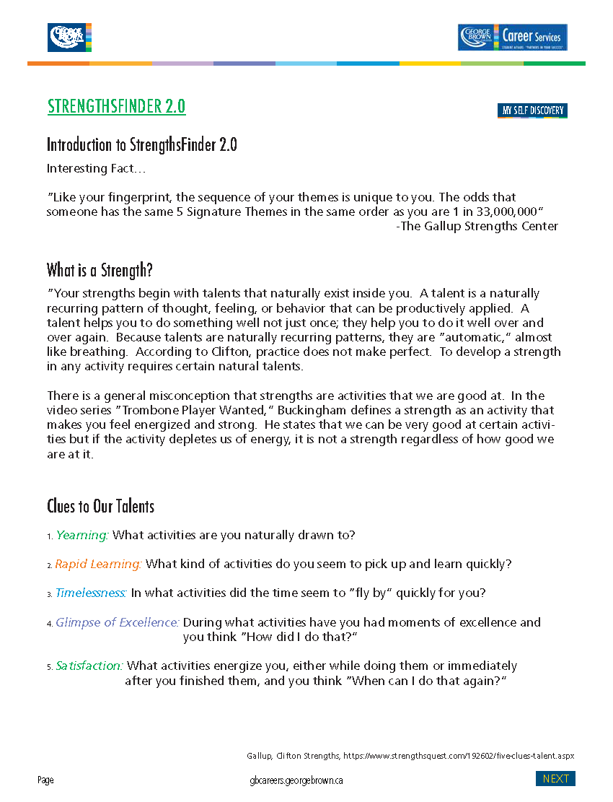

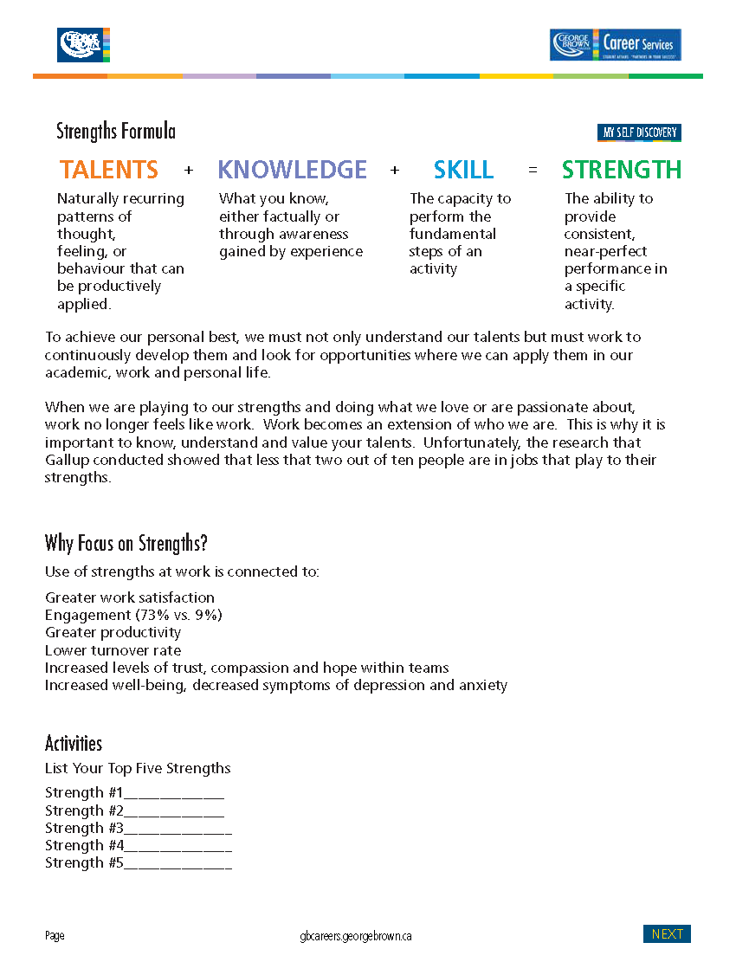



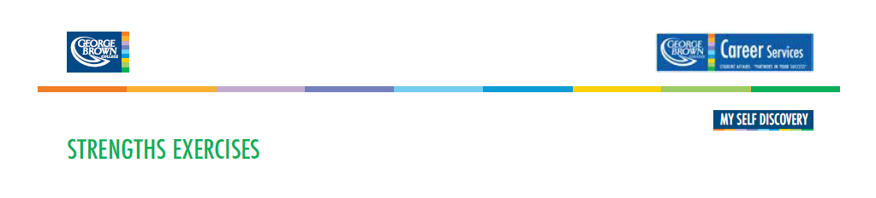

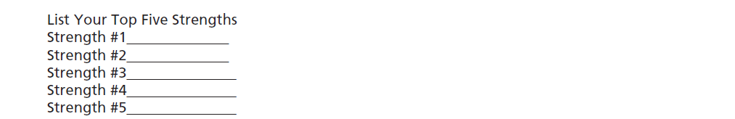

Communication

Woo

Activator

Achiever

Maximizer



When I first read my Clifton Strengths Report, I could definitely relate to all 5 strengths. I am a very direct and task focused individual that likes to take a lead in moving things forward.

As an “**activator**”, I can sometimes be viewed as a dominating and forceful individual when really my goal is to move things along quickly to meet deadlines. I am also very strong at influencing people to achieve their best. When I first saw the term “**woo**” which stands for “winning others over” – I hated this label. I really enjoy people but it is not important to me to “win them over”. However, as I read through the description, it was totally me. I live in the moment and have a natural love for meeting and hearing people’s stories. I find it very easy to engage in conversations with strangers and find that people are drawn to my personality. I also naturally gravitate towards people that appear to be uneasy or uncomfortable in a group setting. I like to make sure that people feeling included, valued and appreciated. I am a very energetic and enthusiastic individual that is able to find the unique talents that people possess. My “**communication**” strength comes out in my love for storytelling. I excel in being able to share relevant stories that evoke strong responses from my audience. As a teacher, I see my role as an entertainer and the genre I specialize in is education. My goal as an educator is not to “dump content” but to engage and excite my students about the learning process. I love using the power of words and voice to convey messages and stories. When standing in front of an audience, I become completely energized and my goal is to entice the group into wanting to know more about a specific subject. As an “**achiever**”, there is nothing that I feel I cannot do. I am a natural problem solver that views challenges as just a new opportunity to approach something in a different way. When I am working on a specific project, I become complete absorbed in the task and will not be distracted until the job is done. It is important that I love what I do, because when I am absorbed in a task, it does not feel like work but rather an extension of who I am. My “**maximizer**” strength speaks to the wonderful feeling I experience when I have successfully accomplished my tasks. It also helps me to focus on my strengths and to seek out opportunities that enable me to play to my strengths. I do not spend a lot of time dwelling on my weaknesses (and never have!) as this does not serve me well – I would rather focus my energy on my strong points and work around the weak areas. Maximizers are strong at identifying strengths in others and excel at helping them to find opportunities where they can utilize their natural abilities. As a maximizer, I am able to develop high performing teams based on this strength.







The discovery I have made about myself going through the strengths identification process is that I can honestly say that I am in a career that taps into 95% of my top 5 strengths. When I broke down my role as a faculty member and Coordinator of Student Success Initiatives at GBC, I realized that I utilize all of my strengths on a daily basis. This is why I am flourishing in my life and career.



There is no particular strengths theme that suits me best. When I reflect on my top 5, they are all very important to the roles I play in my daily life. I find that strengths can be situational - based on the situation, I will tap into different strengths at different times. When I am creating content for a lecture, I move into my activator, communication and achiever strengths. When I am facilitating a class or meeting, my, woo, communication and achiever strengths are in the forefront. In my role as Student Success Coordinator, I lead a 25 person work team. This requires me to utilize all of my strengths as you have to develop and implement programming (activator), achieve work targets (achiever), communicate effectively with stakeholder groups (communication), network your services throughout the college (woo) and build a high functioning team that works well together and delivers (maximizer). There are no particular strengths theme that suits me best. When I reflect on my top 5, they are all very important to the roles I play in my daily life.



I find that strengths can be situational - based on the situation, I will tap into different strengths at different times. When I am creating content for a lecture, I move into my activator, communication and achiever strengths. When I am facilitating a class or meeting, my, woo, communication and achiever strengths are in the forefront.

In my role as Student Success Coordinator, I lead a 25 person work team. This requires me to utilize all of my strengths as you have to develop and implement programming (activator), achieve work targets (achiever), communicate effectively with stakeholder groups (communication), network your services throughout the college (woo) and build a high functioning team that works well together and delivers (maximizer).





I will continue to network with colleagues across the college to find new opportunities to collaborate on new project initiatives.

I find that I continuously need to be challenged by developing new programs and am always seeking out opportunities at the college do to this. This year, I have designed and implemented eight new programs across various divisions in the college.

I utilize this strength in my role at the college by continuously developing new programs and services for Peerconnect, creating new curriculum, and designing workshops and training programs for Career Services.

This strength is beneficial because it makes me very strong in developing and rolling out new projects and programs in a timely manner

**Activator:**  
Can make things happen by turning thoughts into action





Continue to build on my networking skills within and outside of the college. Also, work on my LinkedIn profile to broadcast my skills to a larger demographic population.

I will always need to be in roles that enable me to meet and be in contact with a broad range of people. I will continue to seek out opportunities where I am meeting new people and exploring opportunities to collaborate and work together.

I utilize this strength in my role at the college through various channels. I am always seeking opportunities that enable me to meet new people and find out more about their role at the college. As a result of this, I am often asked to sit on college-wide committees and invited to present at divisional meetings and various functions at GBC.

This strength is beneficial because it enables me to easily approach and talk to people. As a result of this, I am well known and have been able to develop very positive working relationships across the college.

**Woo:**  
Love the challenge of meeting new people and winning them over. They derive satisfaction from breaking the ice and making connections with another person.





I believe that at this stage in my career, the action that I can take further develop this skill is mindfulness and reflection. I have been an educator / trainer for more than 30 years and it is important to step back and reflect on your communication style and how you can continuously adapt and improve what you are currently doing – especially when dealing with diverse groups of learners.

I will always seek out opportunities where I am able to facilitate. I love standing in front of groups whether it is in a classroom or corporate training environment. I also enjoy using my communication strength to gain a better understanding of people so that I can effectively guide and coach them.

I current utilize this strength in all aspects of my work from lecturing, coaching students and staff, facilitating meetings and effectively leading my workplace team.

This strength helps me to be able to clearly articulate my ideas to very diverse groups. I am able to engage people and often excite and persuade them to my way of thinking. Language through verbal and written forms is very powerful medium for influencing and getting my ideas accepted by others.

**Communication:**  
Generally find it easy to put their thoughts into words. They are good conversationalists and presenters.





The actions that I take to further develop this strength is to constantly be putting new ideas forward to management so that I have the opportunity to develop new programming.

Whatever role I choose to take on in the future, it will have to provide me with a high level of autonomy and a wide range of diversity in the types of tasks I am doing. As an achiever, I have a tendency to get bored rather quickly. I love the challenge of taking on new projects and the hard work it takes to roll them out. However, once the project is moving… I am already looking for my next challenge. Variety and continuous change is very important to an achiever.

I currently utilize this strength in all aspects of my work and personal life. I love to delve into complex projects and find myself so focused that nothing can distract me. When developing curriculum, I will spend hours researching and developing new material. At work, I am often involved in managing multiple roles simultaneously which keeps me busy and challenged to produce quality work.

This strength helps me to be productive and to get things done. I am not afraid of being insanely busy – actually, I thrive in this type of environment. The busier I am, the more I get accomplished and the more I accomplish the better I feel! I also have a reputation with my management group of being the go to person if something needs to happen. As a result of this, they will often come to me when a project needs to be developed and rolled out quickly.

**Achiever:**  
Great deal of stamina and work hard. They take great satisfaction in being productive.





Keep focusing on what I love to do and explore more opportunities where my strengths can be utilized in all aspects of my life. It is important to me that I am flourishing in whatever I do.

I will always seek out activities in my professional and personal life that enable me to play to my strengths. I pay very close attention to what energizes me and what depletes me. My next career transition will be retirement and I am currently exploring opportunities that will allow me to continue to play to my strengths within part-time and volunteer work.

I currently utilize this strength in my coordination and teaching role. I am drawn to activities that energize me including curriculum development, facilitating learning, and inspiring my students, staff and colleague to understand their strengths and to explore opportunities where they can be playing to their strengths.

This strength is incredibly beneficial because it helps me to focus on what I am good at. I spend the majority of my time looking for opportunities that will let me play to my natural talents. Because I am acutely aware of my strengths, I am very focused and clear about what I want to do and therefore can give my very best to every project that I take on.

**Maximizer:**  
Focus on strengths as a way to stimulate personal and group excellence. They seek to transform something strong into something superb.



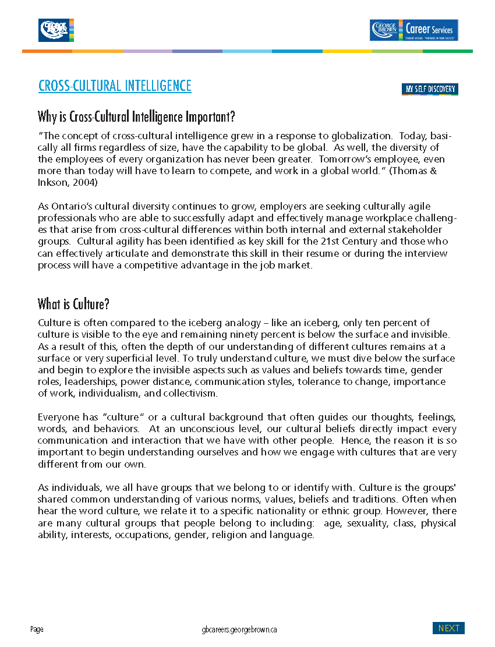

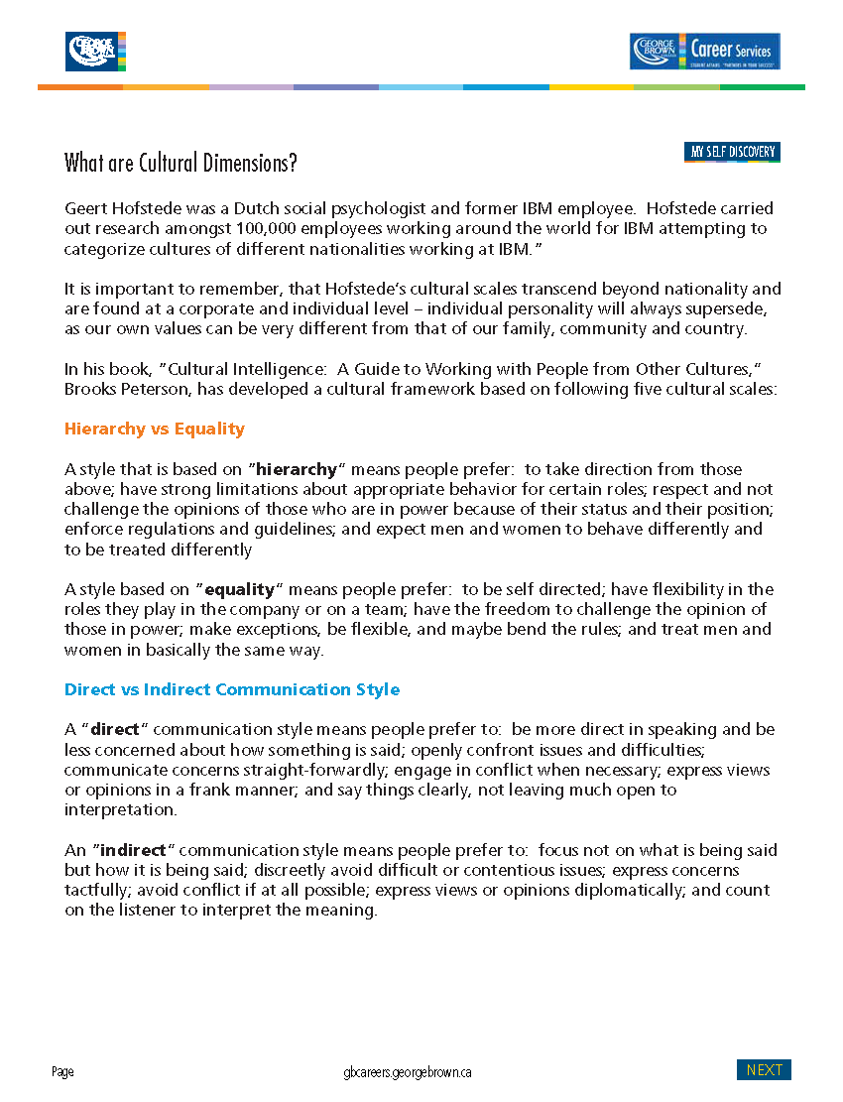

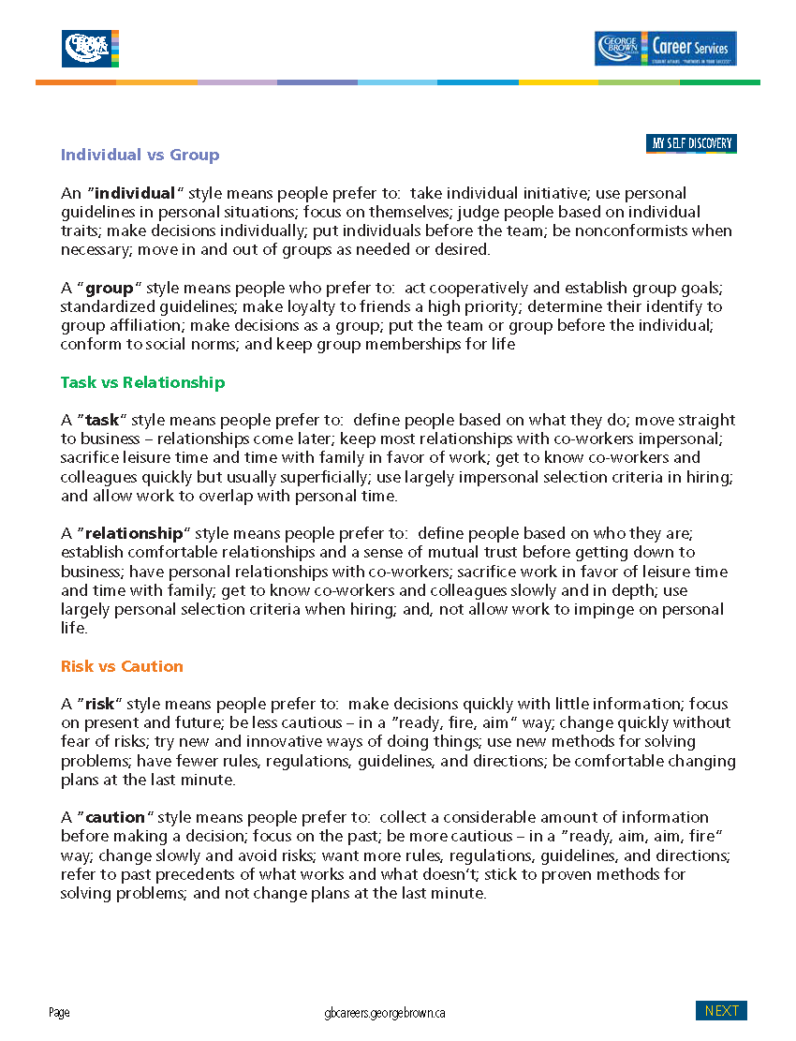

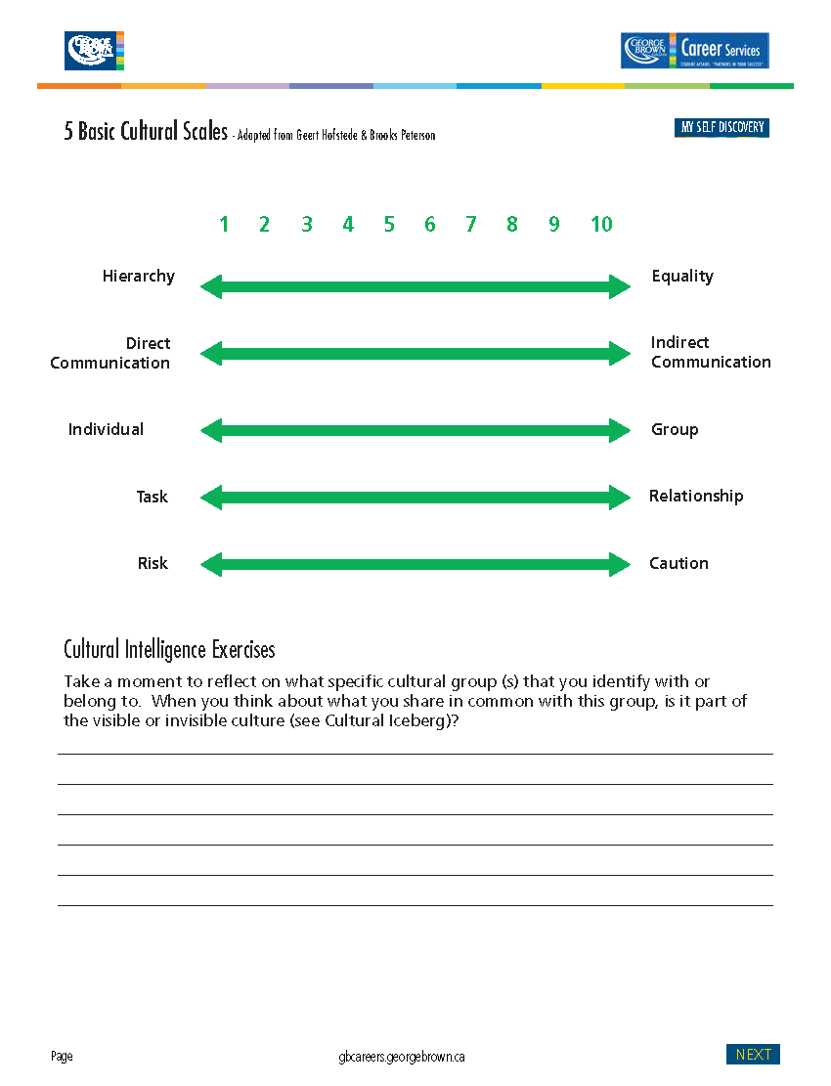





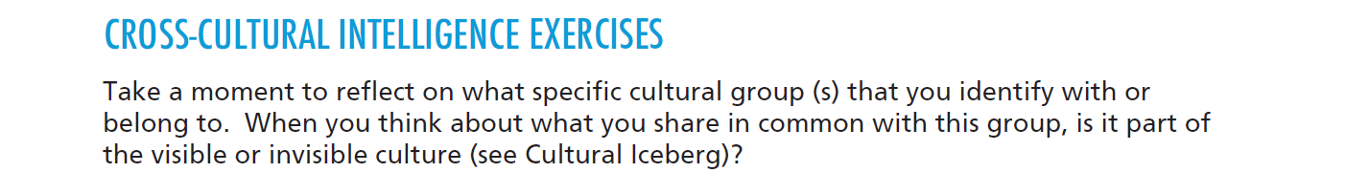

The cultural groups that I identify the most with are age, profession, and interests. My parent’s heritage is a mix of Scottish, English, French, Ukrainian and Russian. With such a mix, we never really identified with one particular nationality or ethnic background. I have always strongly identified with my profession as an educator – to the point, where my New Year’s celebration is September when the school year begins. Many of my closest friends are fellow educators that share a common passion for education and learning. At this point in my life, I am beginning to identify more with my age as I get closer to retirement. I relate more to friends and colleagues that are in the same age group and pondering the same question “what do I want to be when I grow up?” We are entering the next stage or journey of our life which is moving away from full-time employment. From a physical perspective, I am also starting to identify a lot more with age, because of the limitation that you begin to experience as your body gets older. I am simply not able to do the same things I could do when I was thirty! I also spend more time these days focusing on my interests outside of work and connecting with people that have similar interests including mindfulness and wellbeing, tennis, cooking, travel and grand-parenting.

I would say that many of the cultural groups that I identify with would be both visible and invisible. I am drawn to the field of education because of my value and principles (invisible) regarding the importance learning and have education accessible to all. I believe that knowledge is power and we must develop strong critical thinkers that will make good choices for humankind and the planet. As a strong, independent woman, I believe it is important that women are seen as leaders and strong role models (invisible). As a middle (or slightly past) aged woman, I am motivated by my values which include the importance of relationships / family, integrity, honesty and authenticity (invisible). On the visible side, the way I dress is relevant to my profession and age. Our workplace culture is more informal and casual, which is reflective of my personal style. When I think about myself as a 56-year old woman, visibly, I identify with other women in this age group because I look like them and have begun experiencing the same ailments. Finally, the interest groups that I identify with share visible and invisible cultural characteristics. As cook, you can visible see and taste the types of foods that I prepare but below the surface (invisible) is my value to explore and try new things. As a tennis player, you can quickly identify that I play tennis because of my outfit and equipment but below this is the value of competition, technique and precision. As a yogi and meditator, I carry a yoga mat and wear yoga clothing but again below this is the value and belief around mindfulness and wellbeing.





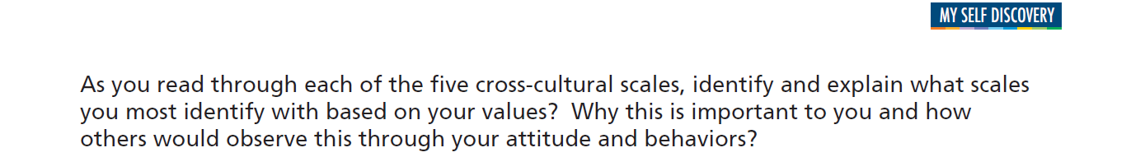

**Based on Peterson’s 5 Cultural Scales, my preferred style are:**

**Equality:** I value working in an environment that enables people to grow to their greatest potential regardless of what position they hold. I want to be able to speak candidly to my managers and be able to provide input into the decision making process. I prefer a more informal environment where people dress casually and speak to each other on a first name basis.

**Direct Communication:** I am all about getting the job done and as a result of this my communication style can be quite direct. I value efficiency and will often say few words to get my point across and appreciate when people can be clear and concise in their communication with me. I want to get to the point quickly so that we can stay focused and meet deadlines. Outside of work, my style can flex based on who I am with.

**Individual:** I value teamwork but if I had my preference I would be to accomplish things on my own. Part of this is about control – I know my work ethic and what I am capable of and find it difficult to rely on other people’s work. I also find that I can produce more when I am in charge of the work schedule. Once I have completed by task, I then like to run it by people to get their input and will adjust accordingly.

**Task:** My motto is “just do it!” When I am at work or home, I become completely focused on the tasks that I am doing and do not like disruptions. I will sometimes get so lost in the task that I can go for days without really connecting with people. I enjoy relationships but work will often come before social. If the work is completed…then I am all about socializing!

**Risk**: I am not the type of person who requires a lot of information to make a decision. I often move quickly and rely a lot on my intuition or “gut” feeling about things. I don’t need to be 100% certain before I make a decision – as a matter of fact, sometimes 30% is all the certainty that I need to move forward. I am extremely comfortable in taking calculated risks – if it doesn’t work out… you can always go back and correct or modify. Some of the greatest inventions have been mistakes!





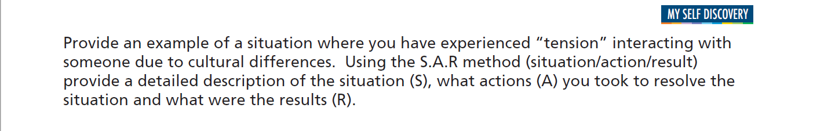

A situation where I experienced tension while interacting with a person from a different culture happened in one of my team meetings. As I mentioned, my communication style is direct and the individual that I experienced the tension with was an indirect style. I was giving my team some feedback on performance issues and noticed that the person completely shutdown and would not make eye contact with me or contribute in the meeting – they became very disengaged. After the meeting, I approached the individual to find out what was wrong and was very surprised by their response. They felt, that I had been rude, critical and disrespectful of the teams’ work and were deflated. I had no idea that this is the way I had come across to some members of the team. My intention was simply to address the business at hand and in my mind there was nothing personal about it. I took this feedback very seriously and set up a meeting with the team to gain a better understanding of how people were feeling. As a result of this, my approach became very different. I started my meeting focusing first on what the team was doing well and expressing gratitude. I also changed the way I framed information so that it did not come across as a criticism but rather an invitation to how we could make improvements together. By doing this, it completely changed the dynamic of my group meetings which improved morale, productivity and quality.



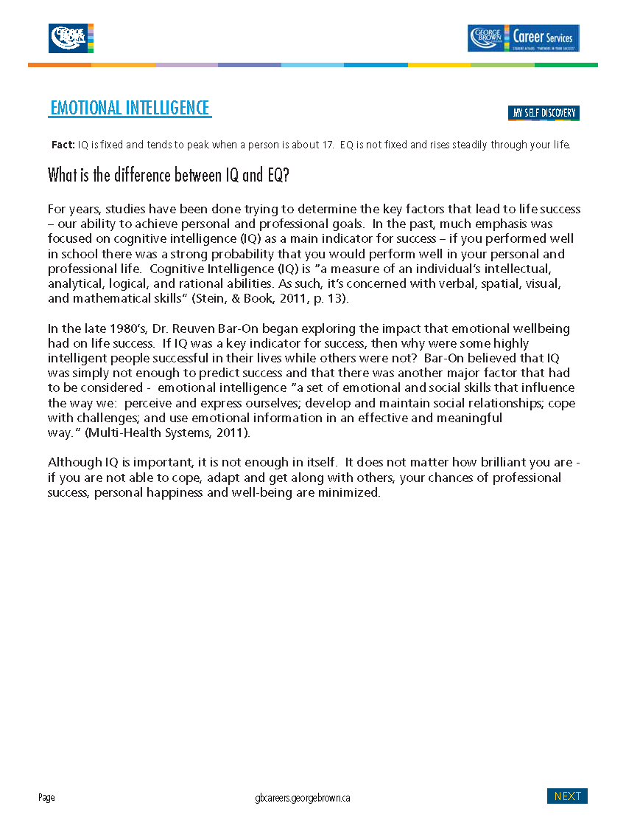

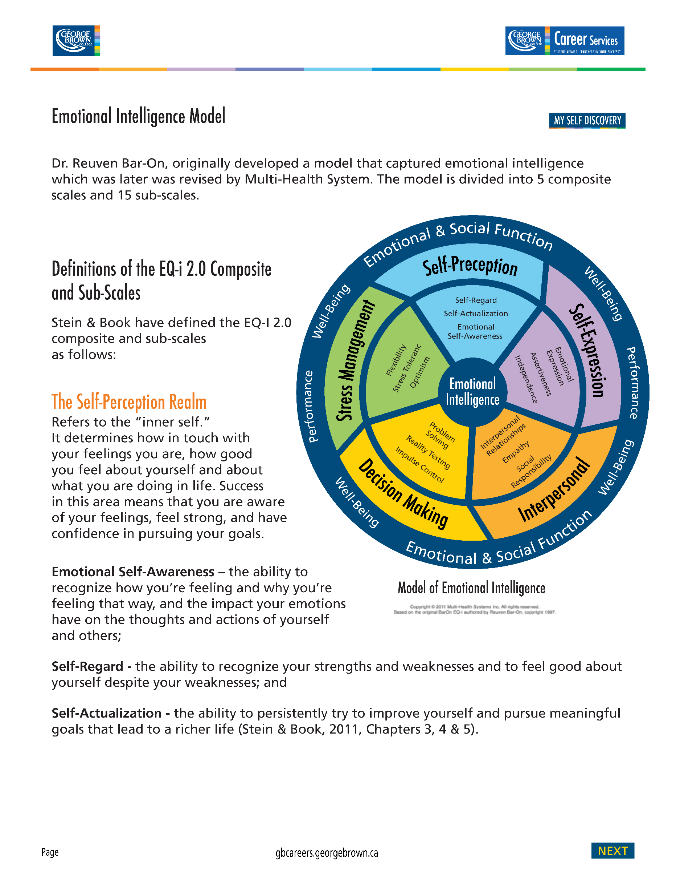



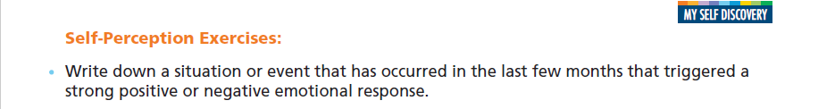

Recently, I had a strong emotional response to a family member who felt that I had treated them unfairly.



In this heightened emotional state, I began experiencing fatigue, as well as, back and headaches. I quickly became angry, impatient and frustrated at this person and wanted to lash out at them.



The feelings that were triggered by this experience were hurt and anger. I was hurt that the person did not appreciate all the support I had given to them and angry that instead of being appreciative they were critical and judgmental.



The circumstances that negatively contributed to this strong emotion was that I was hearing it through another party which often can complicate the issue.



Instead of directly talking with the person, I was negatively influenced by the opinions of other family members. Instead of trying to understand and resolve the situation, I went into a defensive state. The family member I was experiencing the tension with, in turn, became defensive and communication completely shutdown between us.



As communication is one of my top 5 strengths, I should have used this to constructively approach the situation to find a positive resolution to our differences. This is the funny thing about the power of emotions – when you are in a heighten state of emotion, logic and communication are often the first things to go.



Under the Self-Perception composite scale, I could have spent more time on developing my emotional self-awareness. Perhaps, taking more time to reflect on my feelings and to gain a greater understanding as to why I was having this reaction. I also could have spent more time crafting a response that would take into consideration the needs and concerns of both sides.



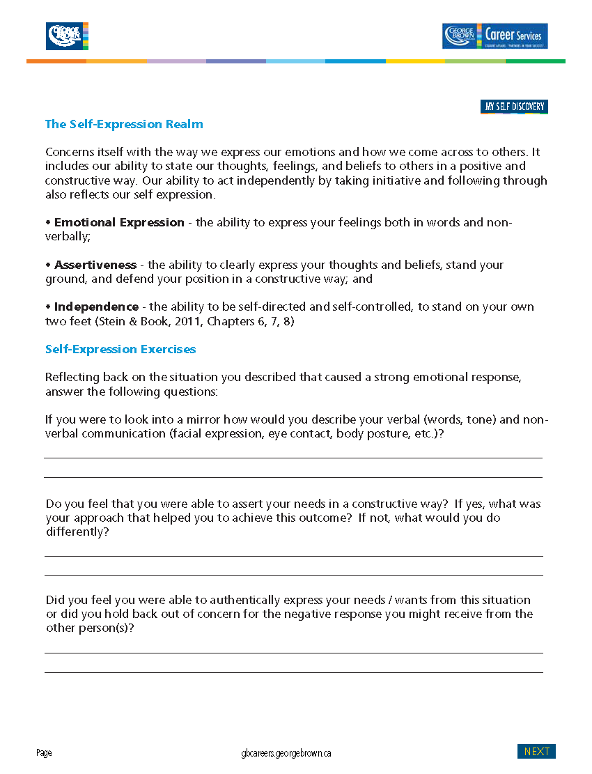





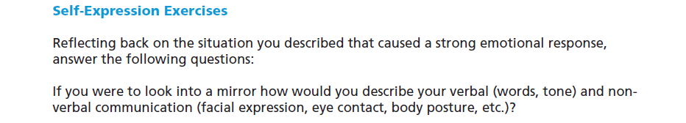

In this situation, I would describe my verbal and non-verbal communication as angry, defensive and closed minded. My language was very accusatory and judgmental. I found myself raising my voice and speaking very fast at my family members. I was more concerned with getting point across than hearing their perspectives. My face looked angry and my body was rigid and I was ready for the fight!



I certainly was able to get my point across but it was in an aggressive versus assertive manner. If I could erase the situation and start over again, I would talk less and listen more to gain a greater understanding of the other’s person’s feelings and concerns. Instead of judging, I would try to be more open and objective and put my personal feelings aside.



I do not have a problem authentically expressing my concerns and needs. However, because I am a direct communicator and am very comfortable stating what I am feeling, I can often shut people down who have a less direct and less assertive style. I can also come across as self-serving and putting my needs before the needs of others because I am quick to assert myself.



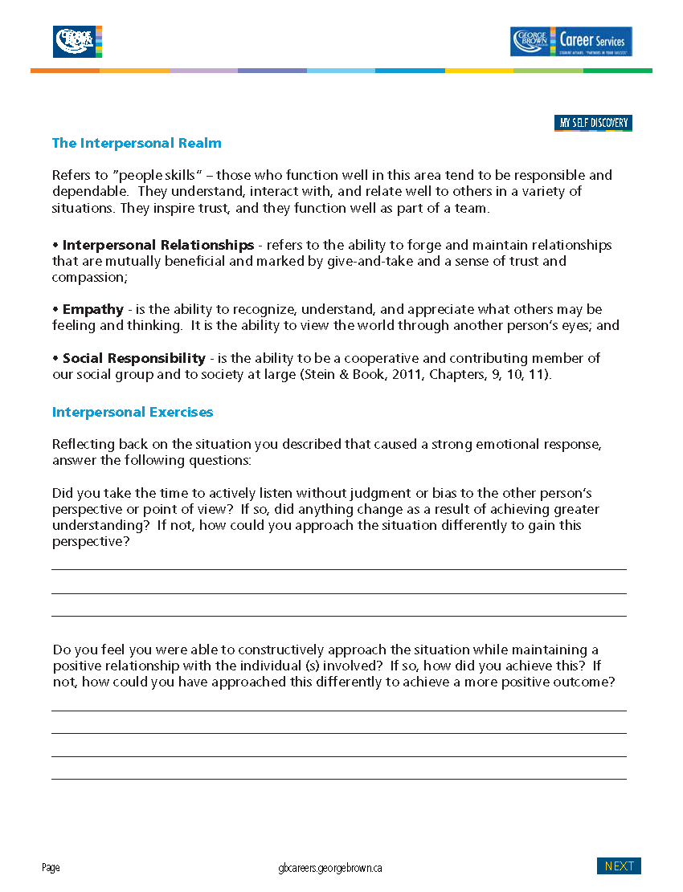





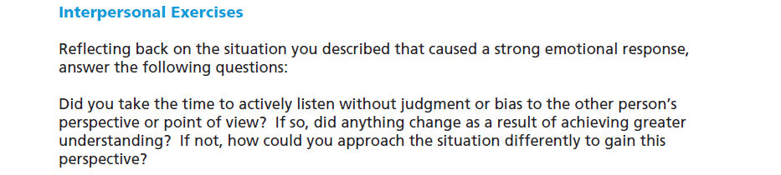

In the heat of the moment, I was only thinking about my own needs. I did the “leap of abstraction” where I took a little bit of information and made a whole lot of assumptions which just fed my negative emotional state. Normally, I would just fire off an email letting the person know how their behavior had negatively impacted me. However, this time I held back and let myself process my feelings before reaching out. Once I had done, this, I began to think about how they were feeling and what their views might be. As a result of this reflective pause, I wanted to understand their perspective and find a common ground where we could begin seeking solutions together.



As I learn more about myself, I understand the need for quiet reflection before action. When the incident initially happened, I was not in a constructive mindset. My instinct was to lash out and tell the person exactly what I was thinking of them which would have been detrimental to our relationship – it is important to remember you can never take back what has been said! By demonstrating impulse control, I was able to pause and think things through. Once I had got over the initial negative emotional response, I was able to approach the situation in a positive and constructive manner that was solution focused rather than defensive. As a result of this, the outcome was very positive for both parties.



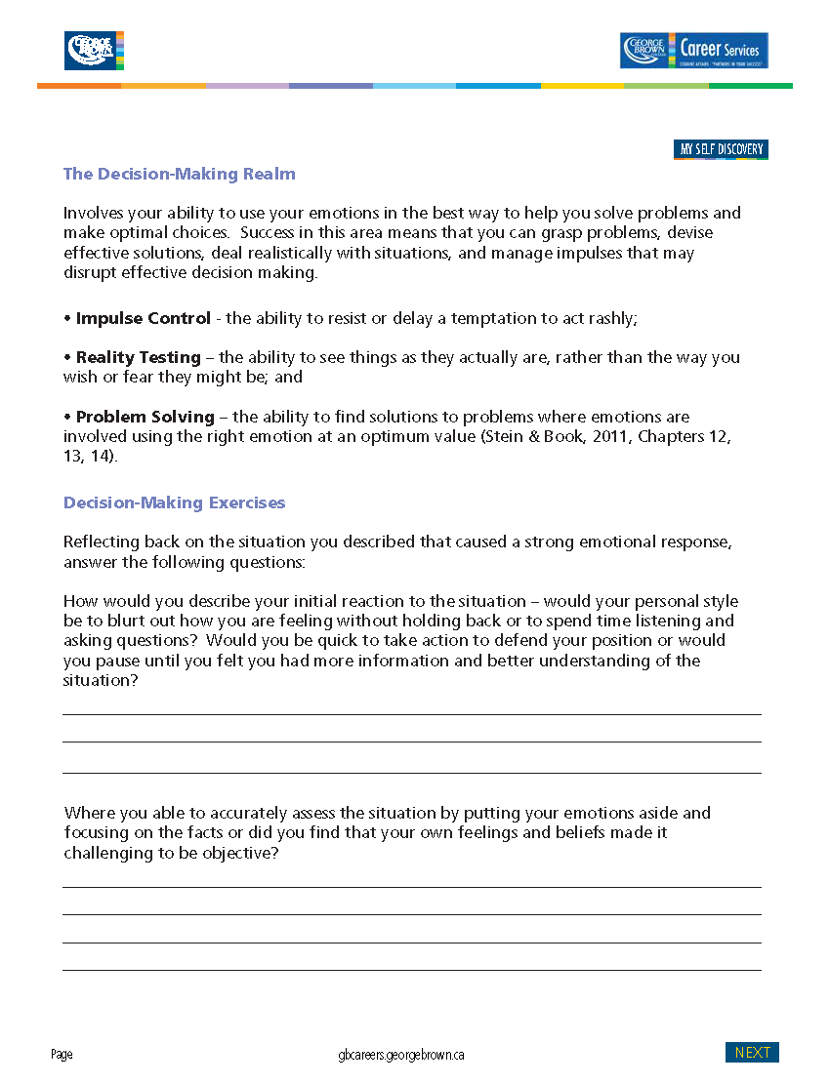





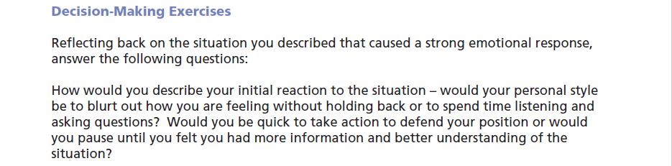

When I am in a heightened emotional state, my backup behavior is to quickly react and to lash out and sometimes verbally attack. Impulse control is something that I have struggled with all my life. I will often have an overwhelming desire to act quickly in need to defend my position. By doing this, I miss out on key information that could have completely changed my response. I sometimes get clouded by my own emotions which can negatively impact my judgment and create a bias for how I see things – my lens can become incredibly narrow.



As I learn more about emotional intelligence and work on developing specific skill areas, I have been able to delay my response (impulse control) by taking time to breath and reflect on what is happening and why I am having a negative reaction. When I calmly think things through and try to understand the other person’s perspective, I find that often there is no bad intention only different perspectives that need to be further explored.



After I calmed down and was able to put my emotions aside and look at things objectively, I invited my family member for a coffee so that we could communicate “live”. I find that texting and emails are a very bad way to communicate when there is tension because you cannot read the other person’s body language which makes up 93% of communication. What your write and how the receiver interprets those words can be like speaking two different languages. We did meet for coffee and my goal was to actively listen and to seek understanding. It is quite amazing the different results that you will achieve when your approach is solution focused instead of defensive! We were able to have a meaningful conversation and we walked away feeling very connected.





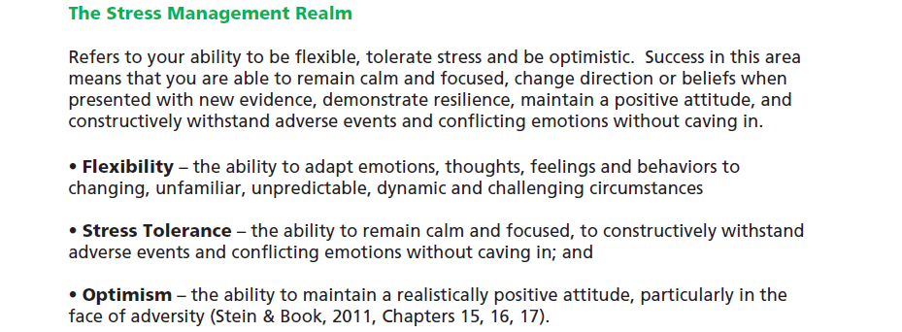



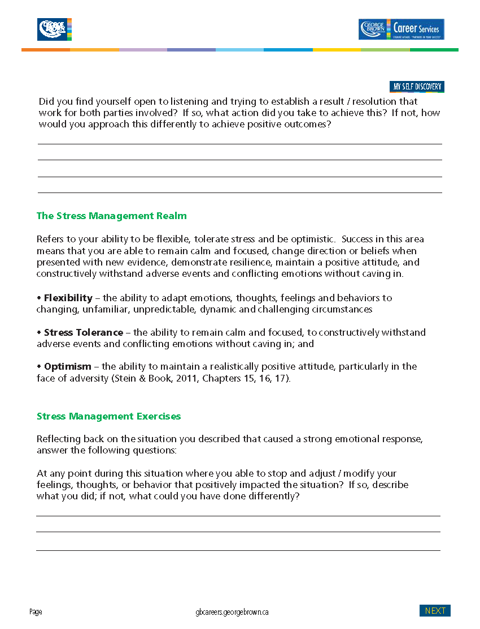

Once you move out of defensive mode and are open to hearing and understanding, anything is possible! Defensiveness is a normal human reaction. The question we have to consider is “how important is the relationship to me?”. If the relationship is important then we must analyze our feelings and modify our behavior to achieve positive outcomes. By stopping and reflecting on my feelings and then honestly asking myself, “is my need to defend my position worth hurting my relationship?” The answer was no. I spent a great deal of time thinking about my approach and ultimately, I wanted to understand and resolve. I actively listened to them and asked questions for greater clarification. In the end, our “wants” were similar in nature and it was easy for us to move forward with both parties being mutually satisfied with the outcome.

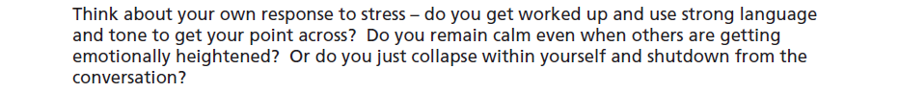

When they talk about people’s emotional response to stress – fight, flight or freeze – I am definitely a fighter. My body become rigid as it prepares for the fight and I am capable of verbally attacking the perceived opponent. Over the years, I have worked very hard at controlling my impulse to immediately react as I have found that it never pays off to respond when you are in a negative emotional state.



I would consider myself a very optimistic person. I see the cup as half full versus half empty. I see opportunities in challenges and believe there are always solutions. I also believe in the internal locus of control – that we do have control over our outcome. One of my favorite quotes is by Jack Canfield “you cannot always control the things that happen to you in life – what you can control is your reaction which controls your outcomes.”



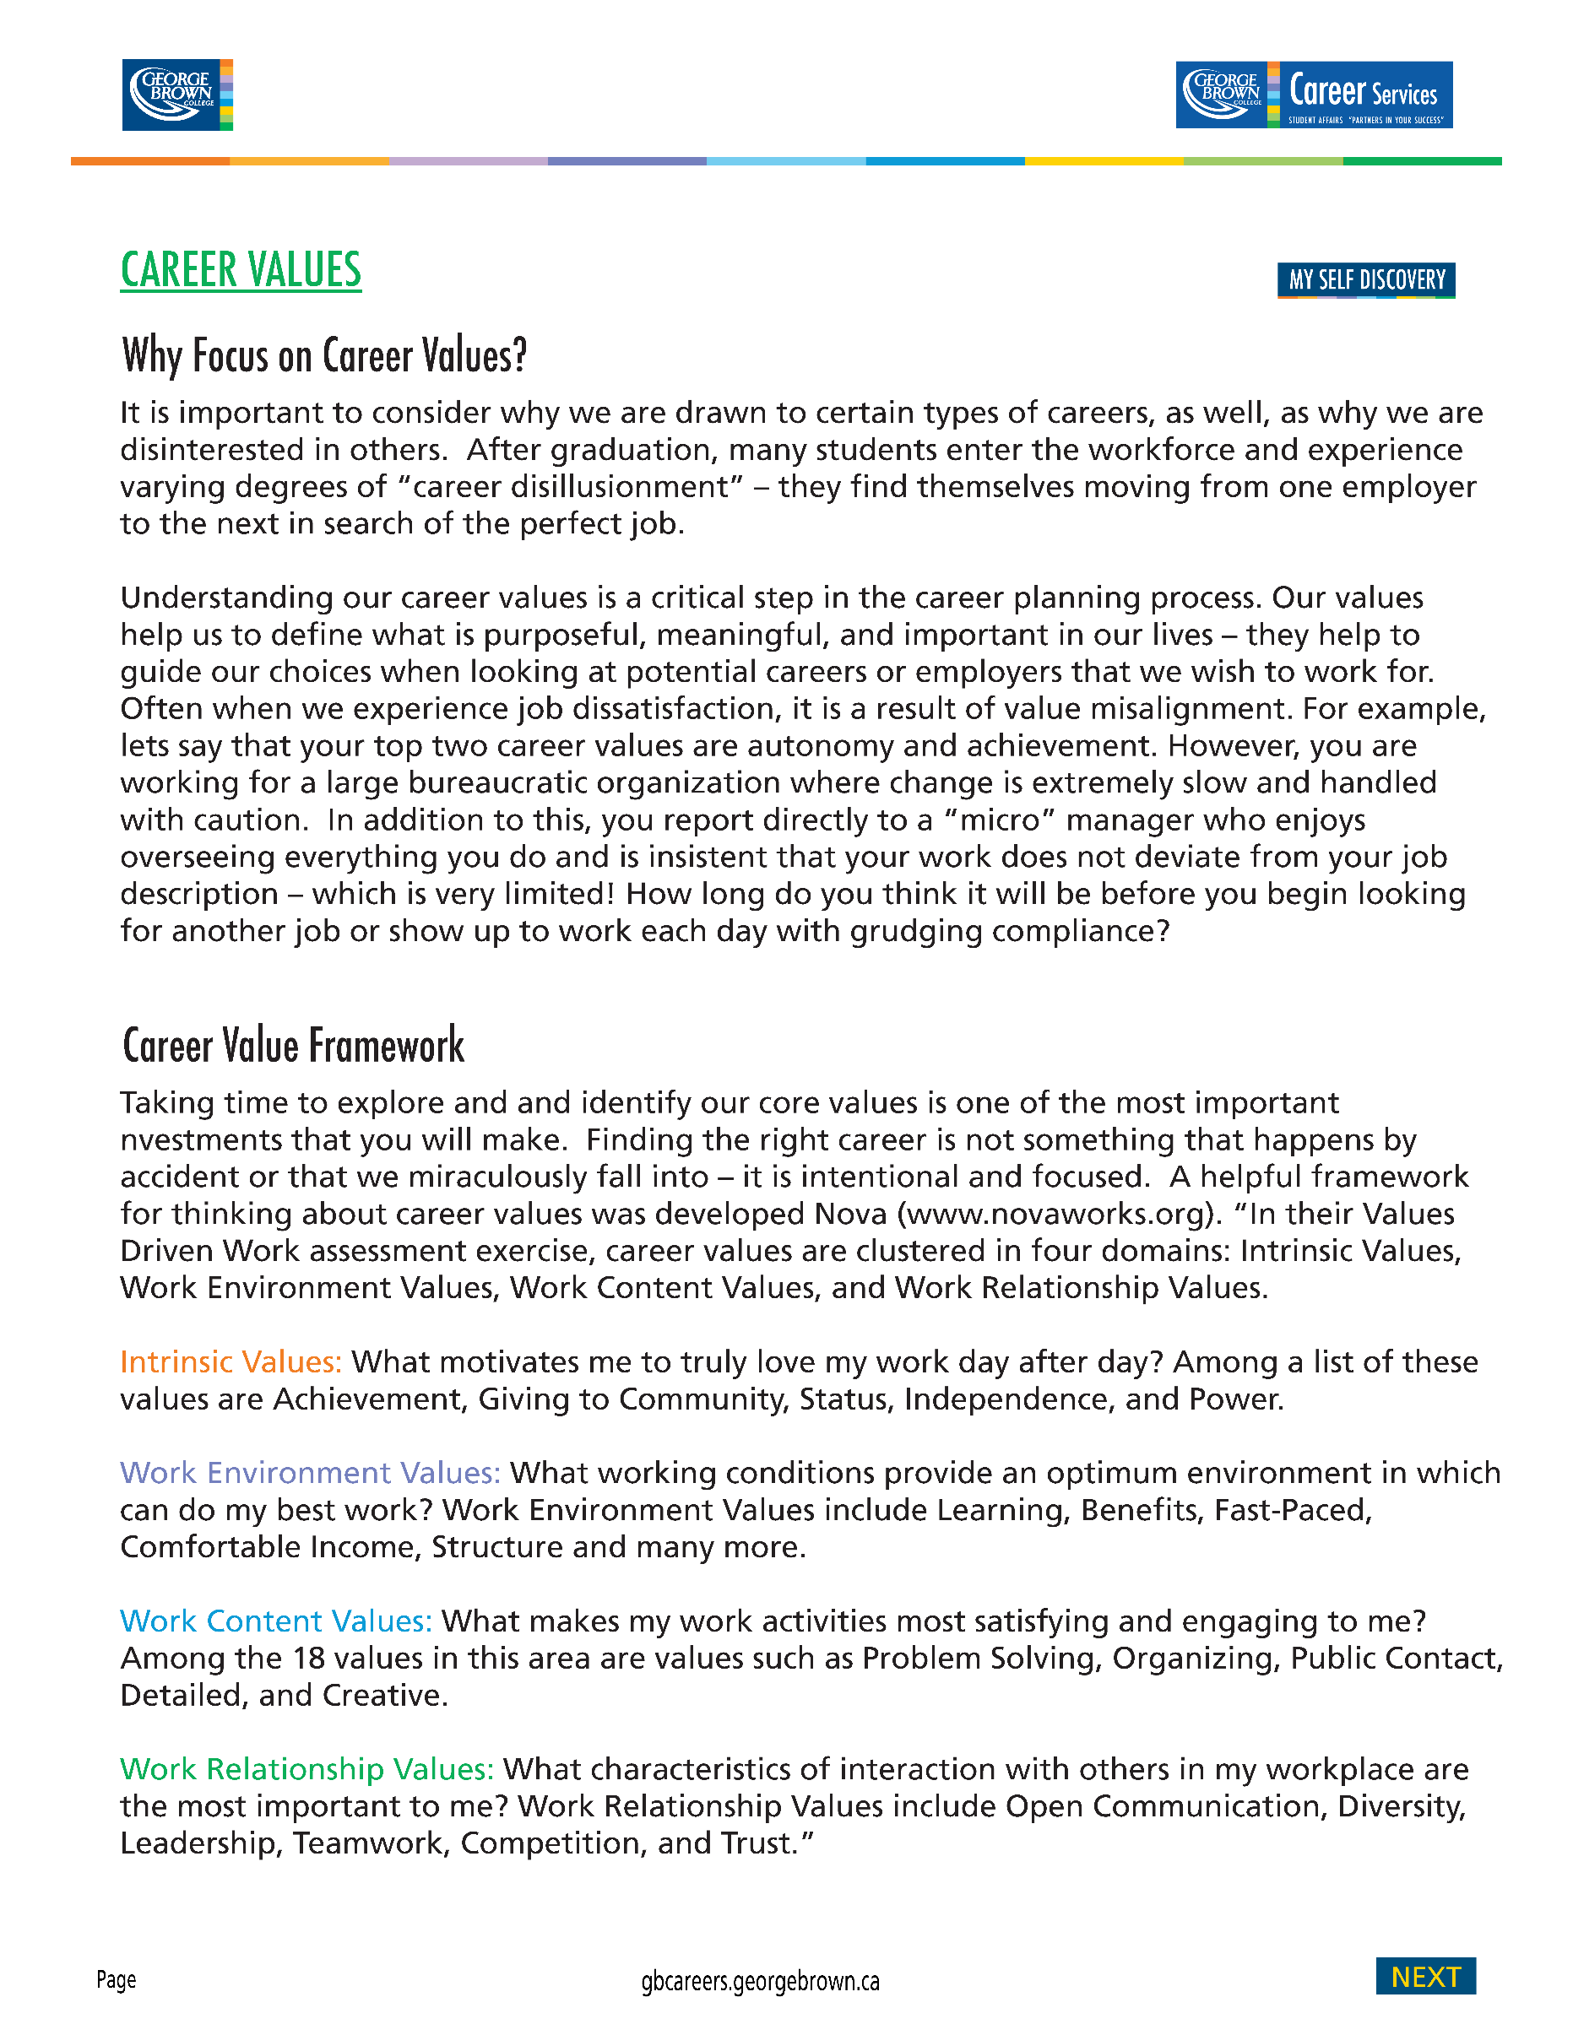

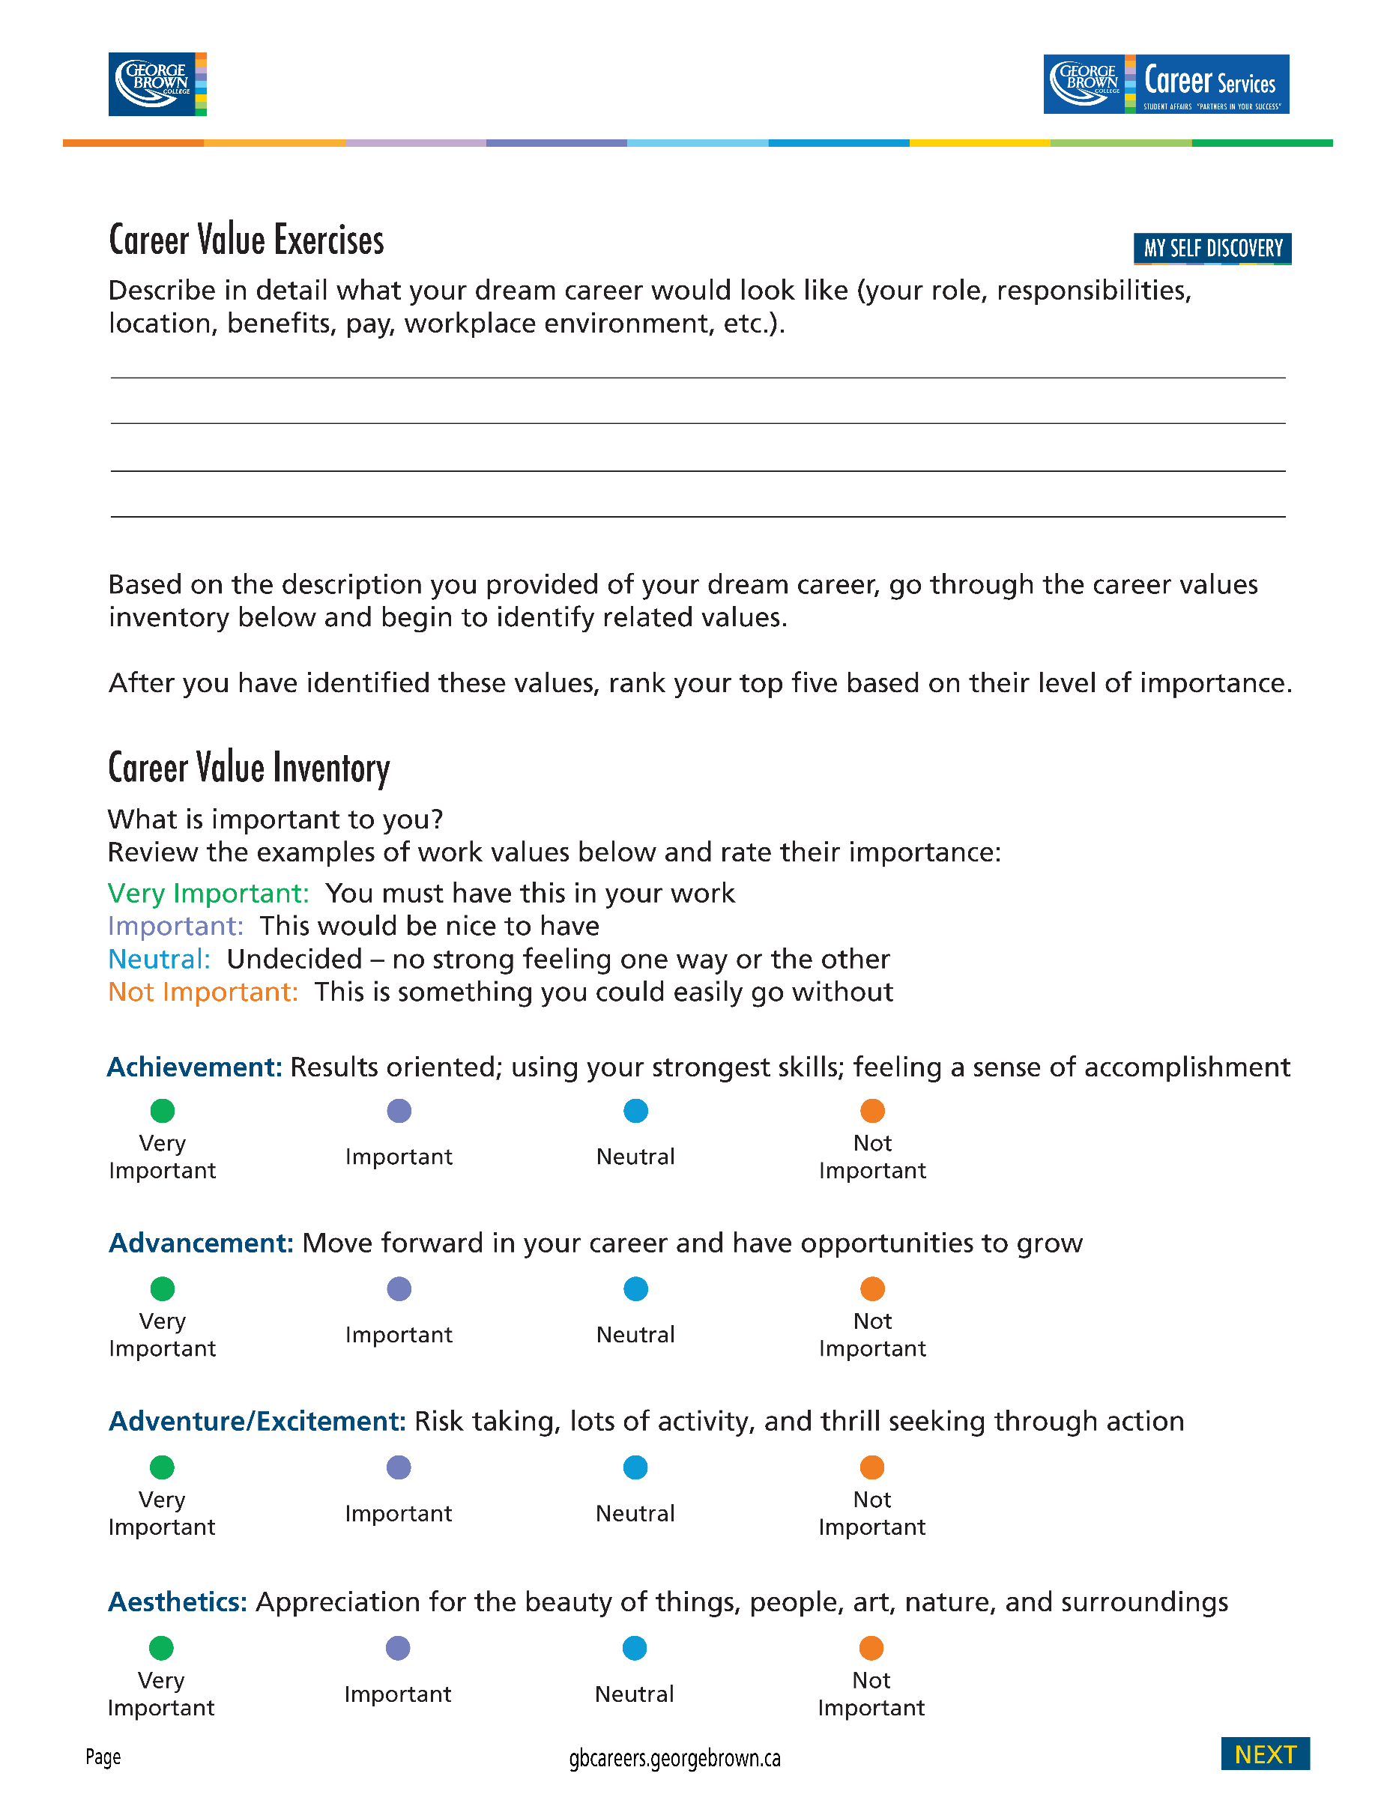

My dream career would be to travel around the world teaching and training within educational and corporate environments. I love traveling to countries that are significantly different in culture from North America and experiencing their values, traditions and belief systems. As an educator, there is much personal growth and development when you are teaching in a system that is very different from your own. It forces you to move out of your comfort zone and adapt your style to meet the needs of the learners.

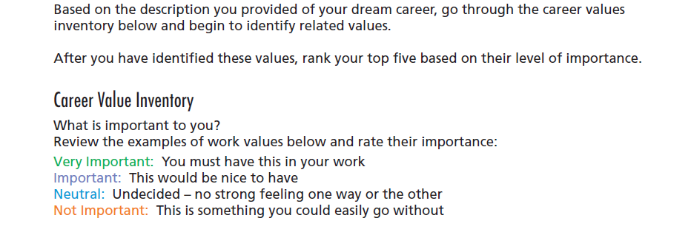

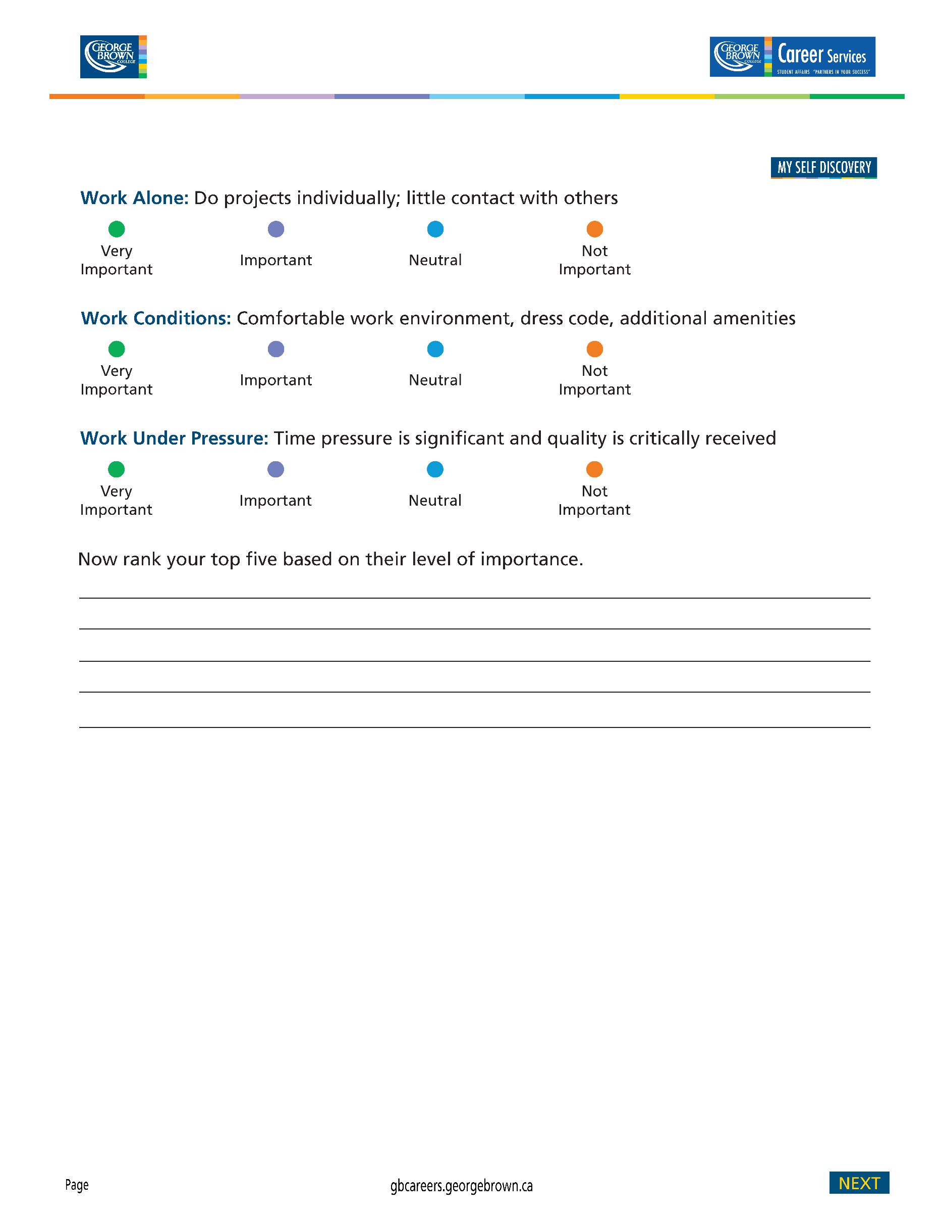

My top career values would be:

* **Creativity**: Express new ideas, programs and services
* **Autonomy**: Work without constraints of supervision; the ability to make decisions without consult
* **Influencing others**: Having significant impact on others to change attitudes and opinions
* **Leadership**: Inspire, motivate or direct others
* **Personal growth**: Opportunities to grow as a person



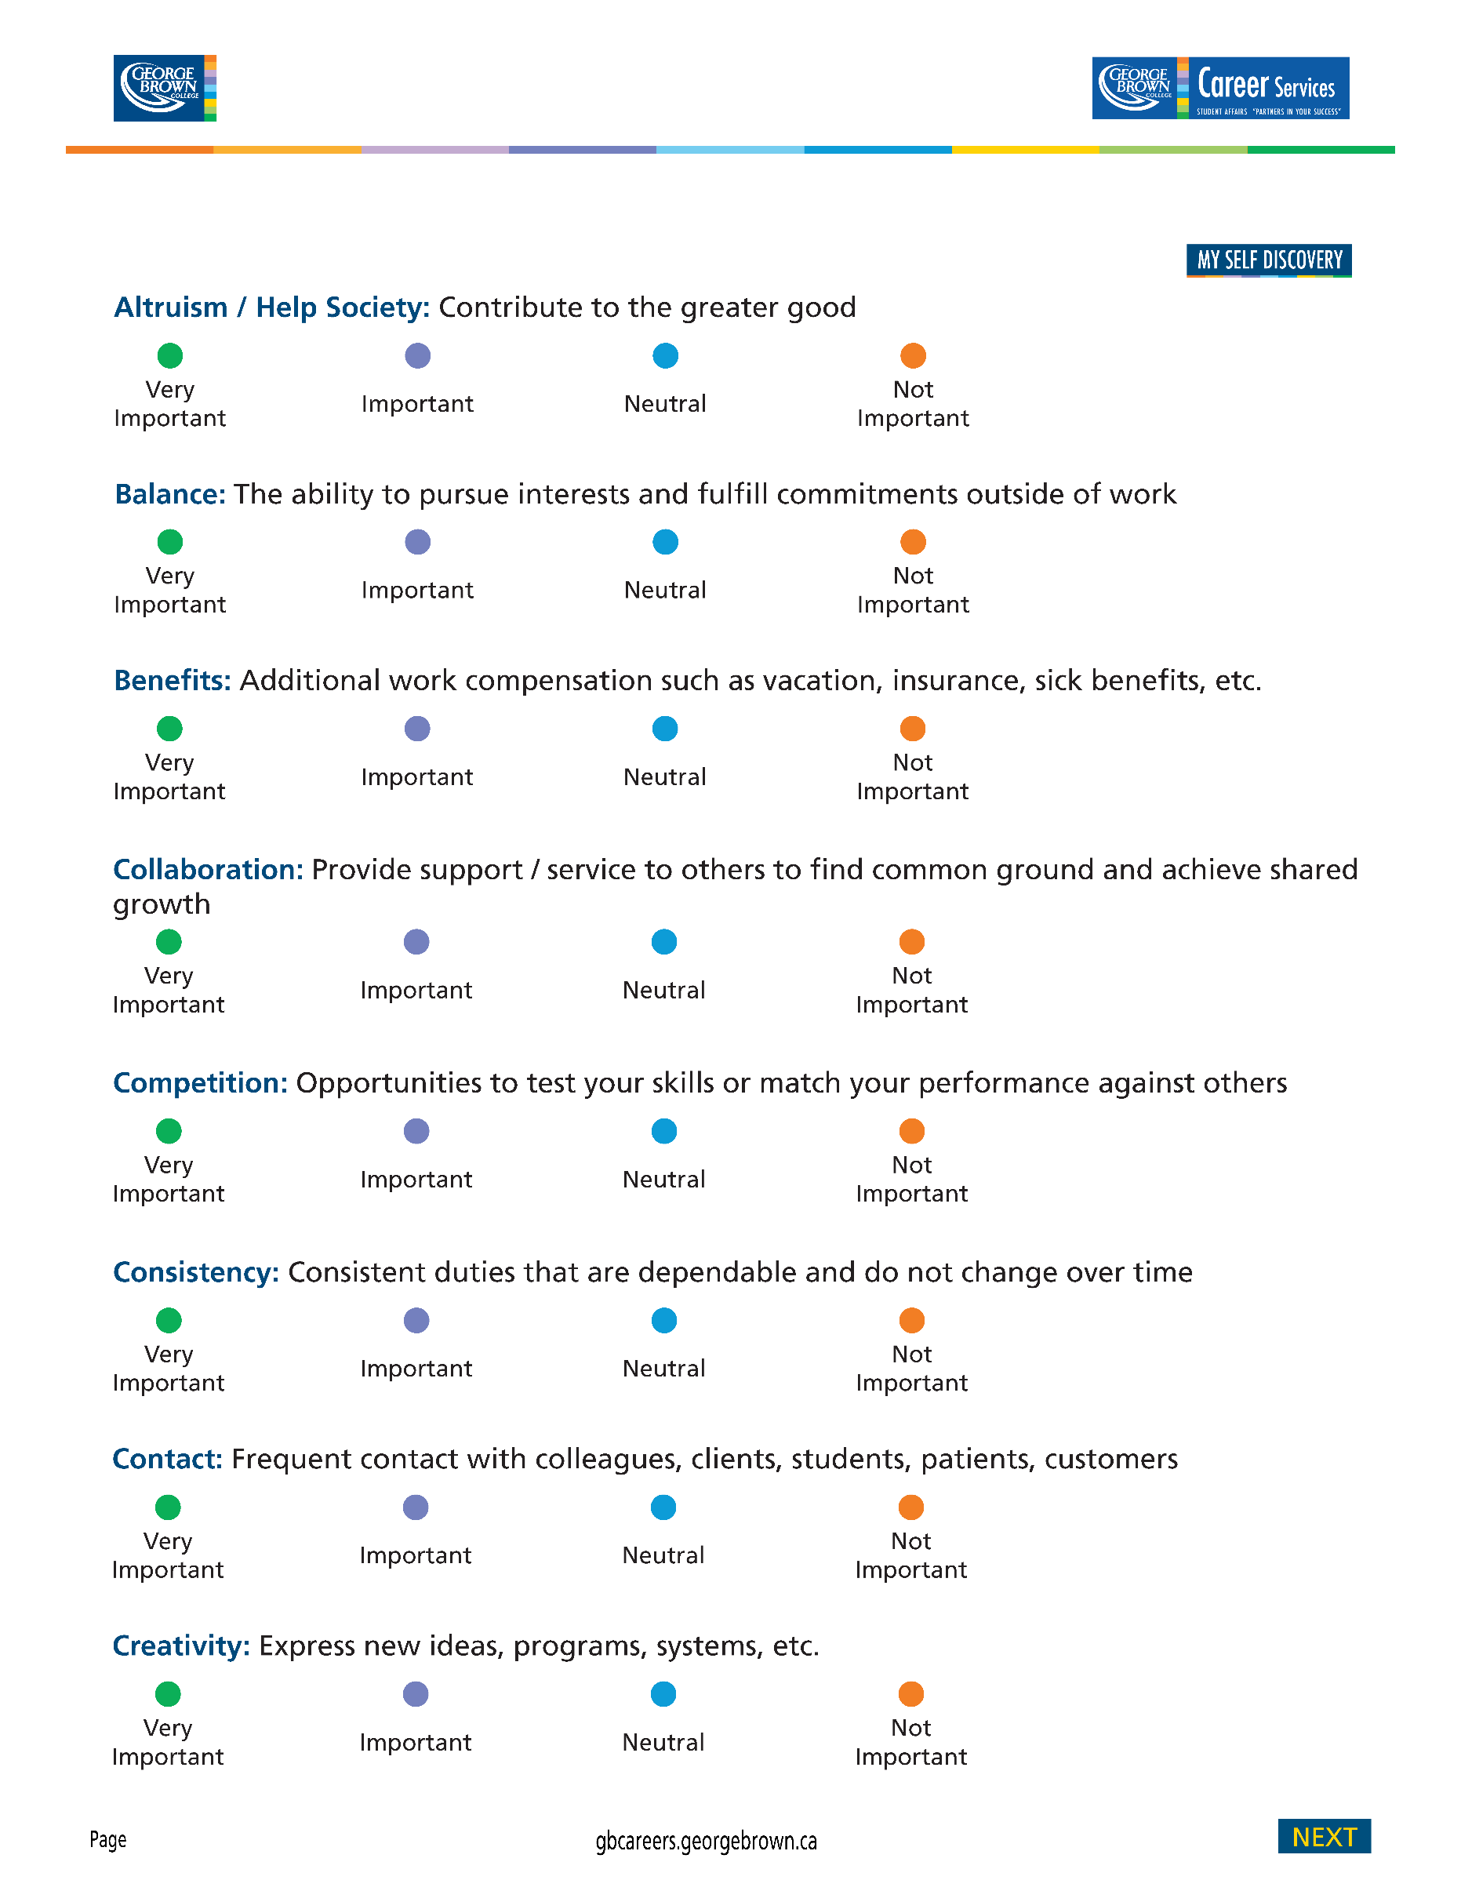

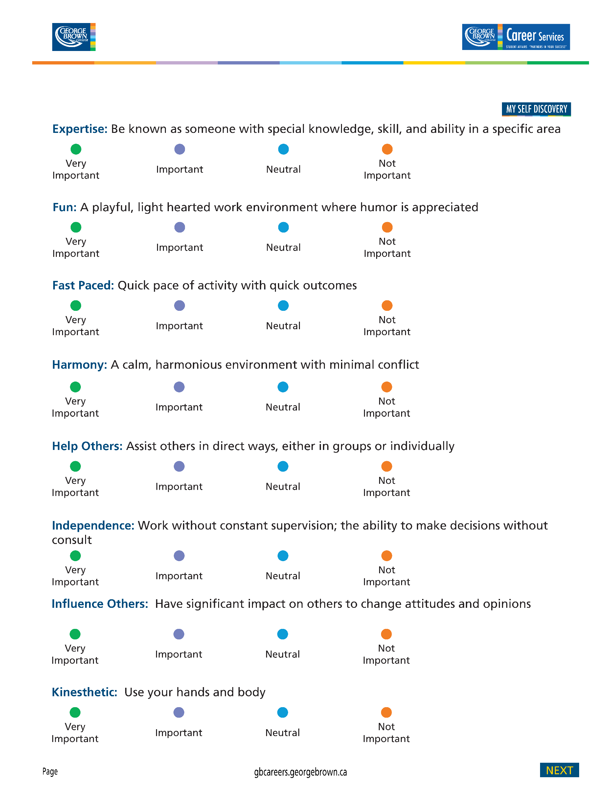

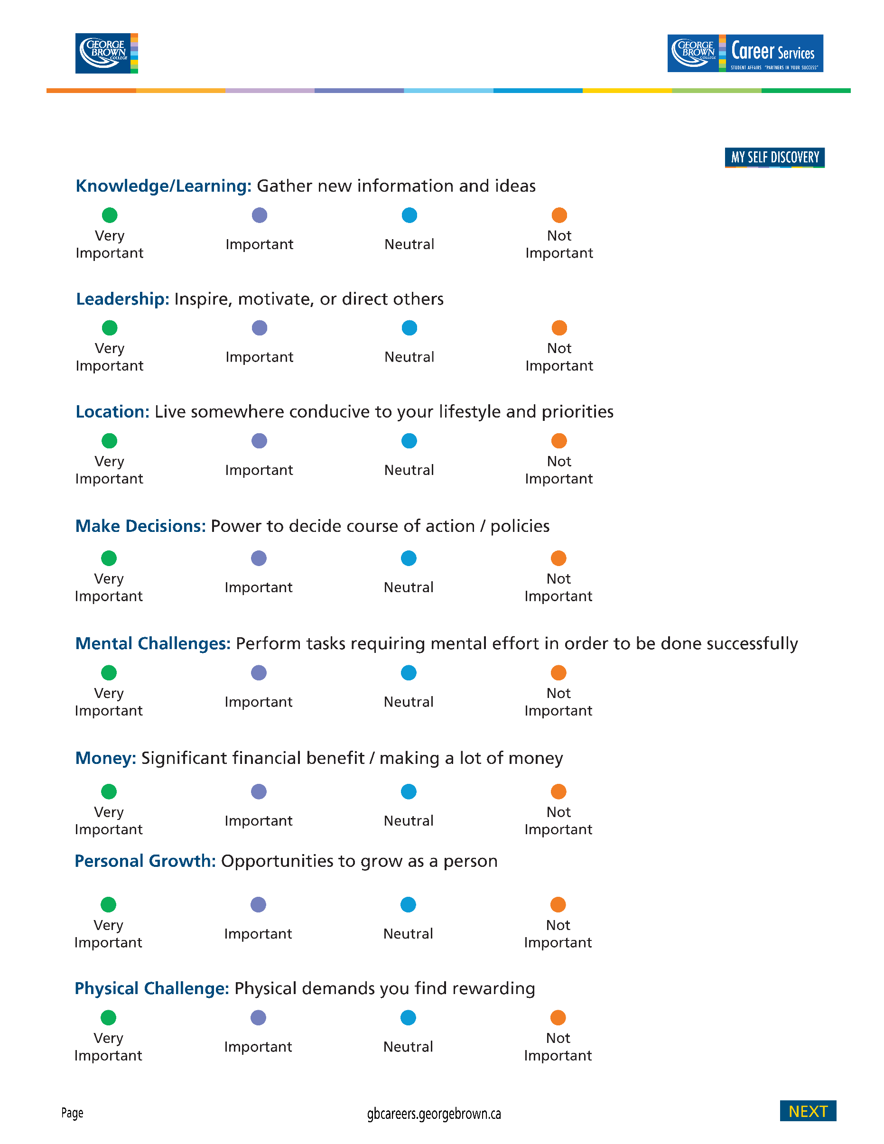

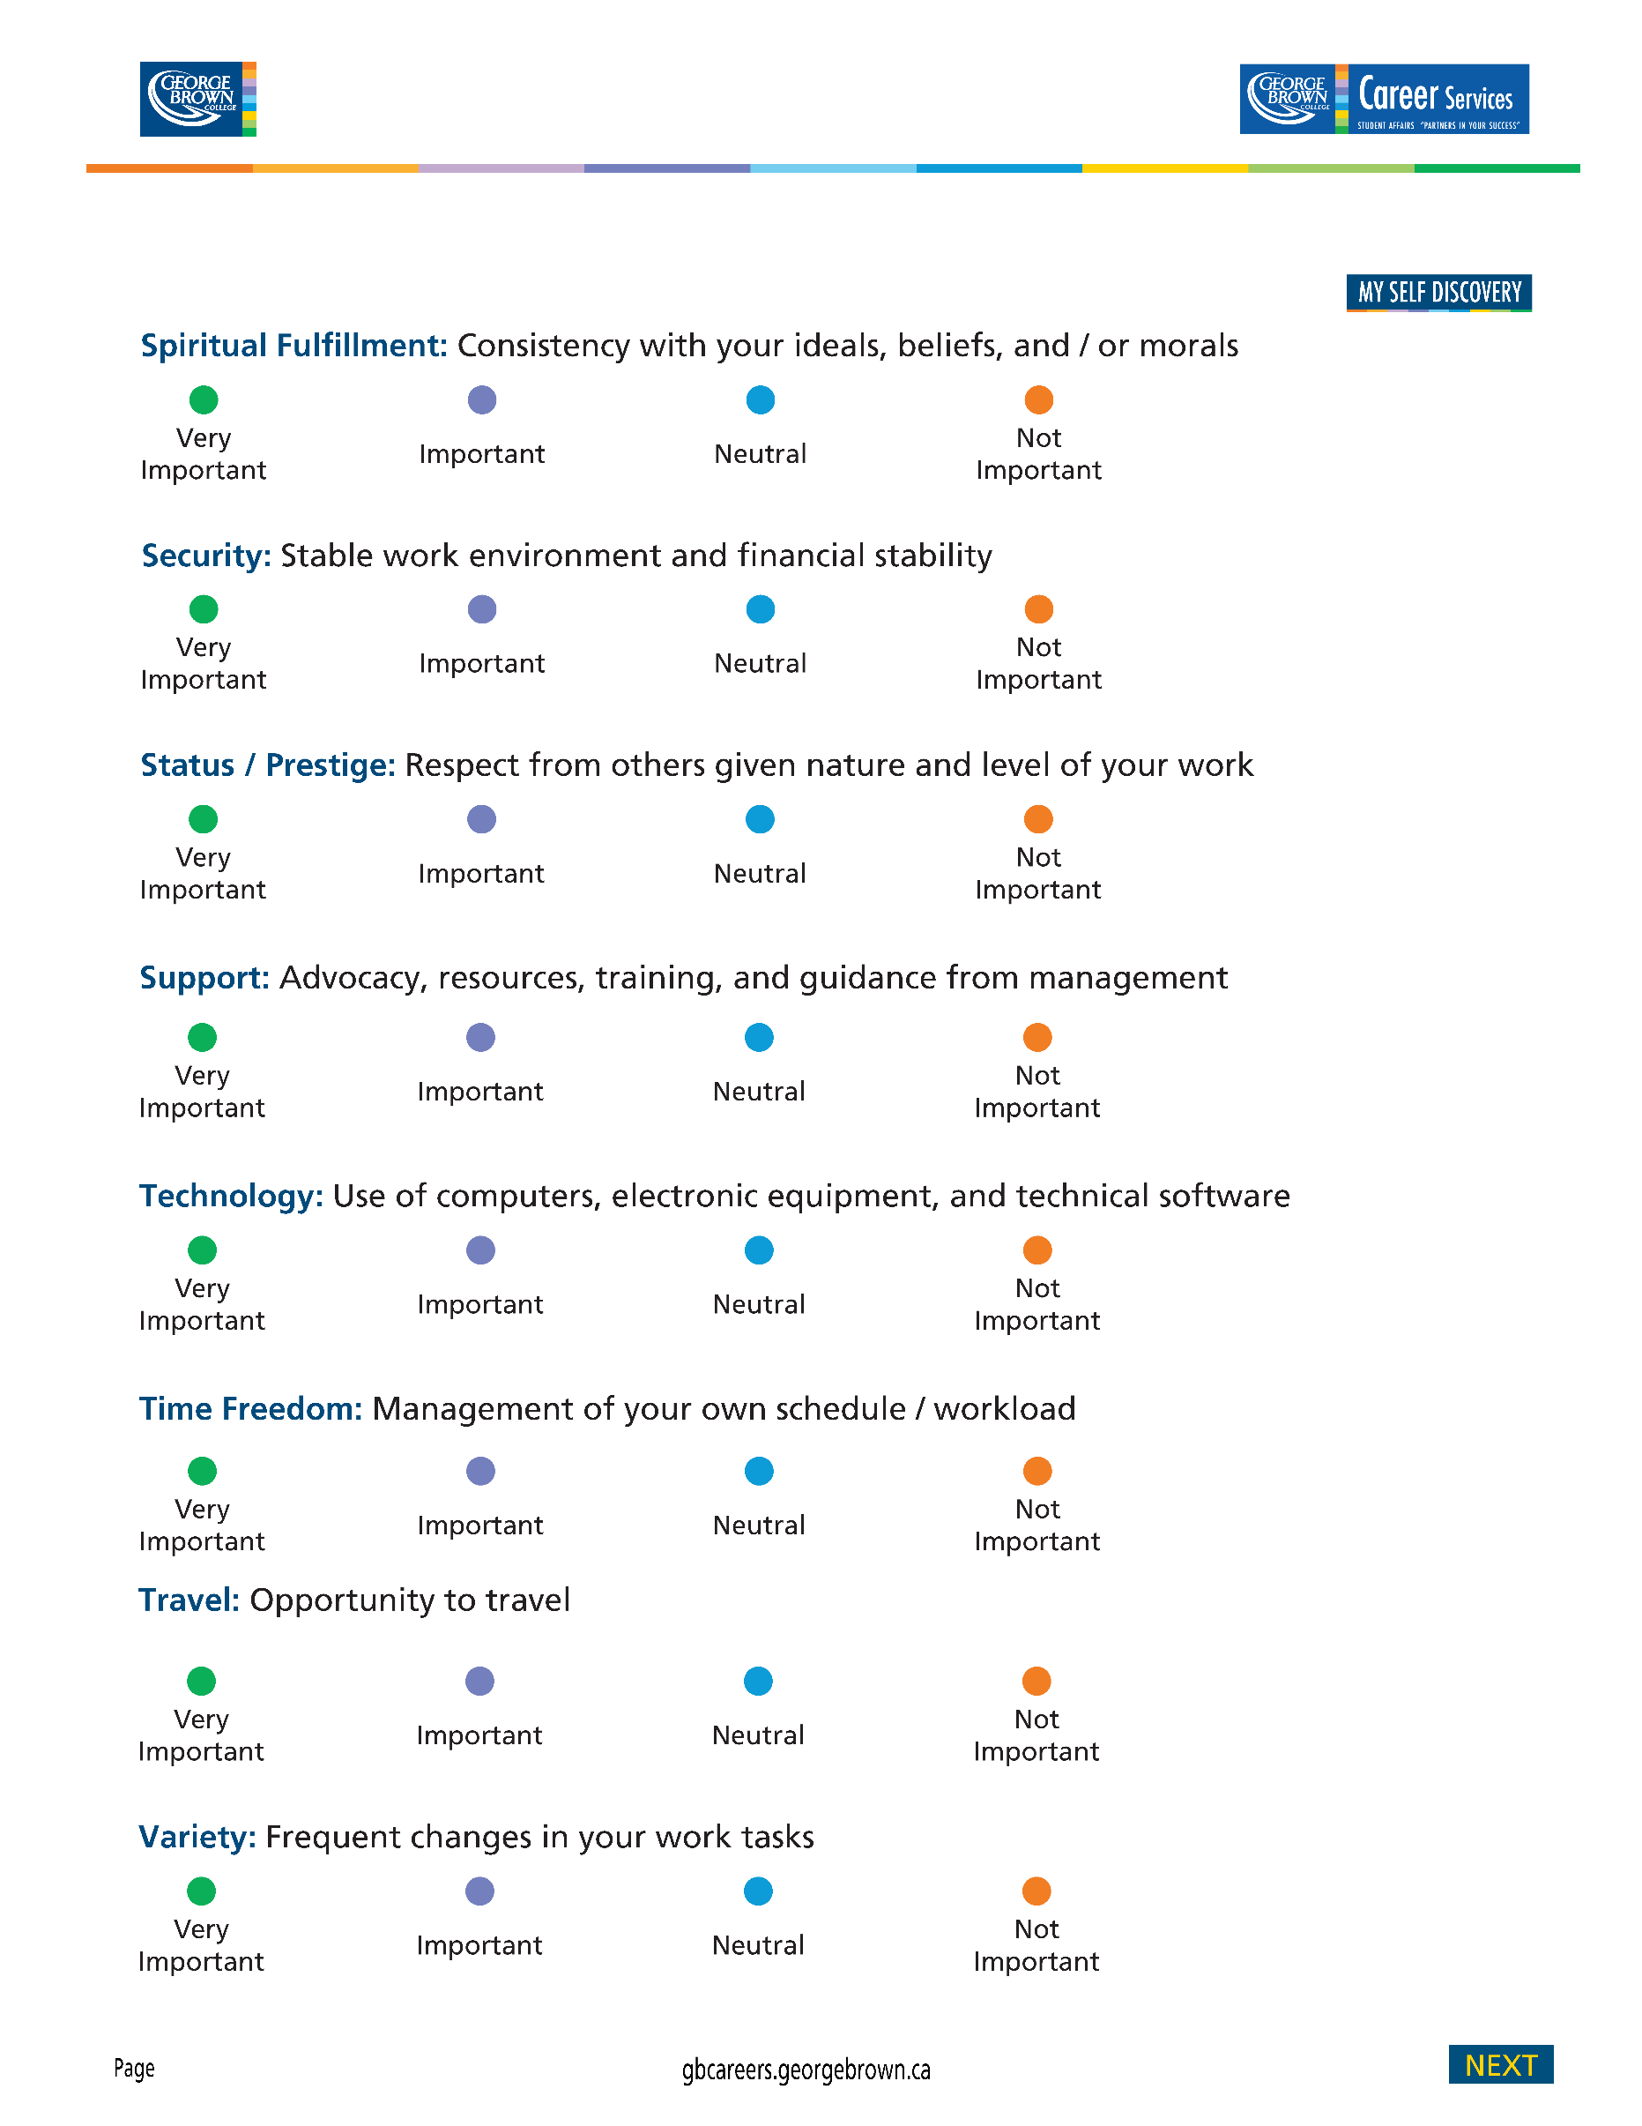

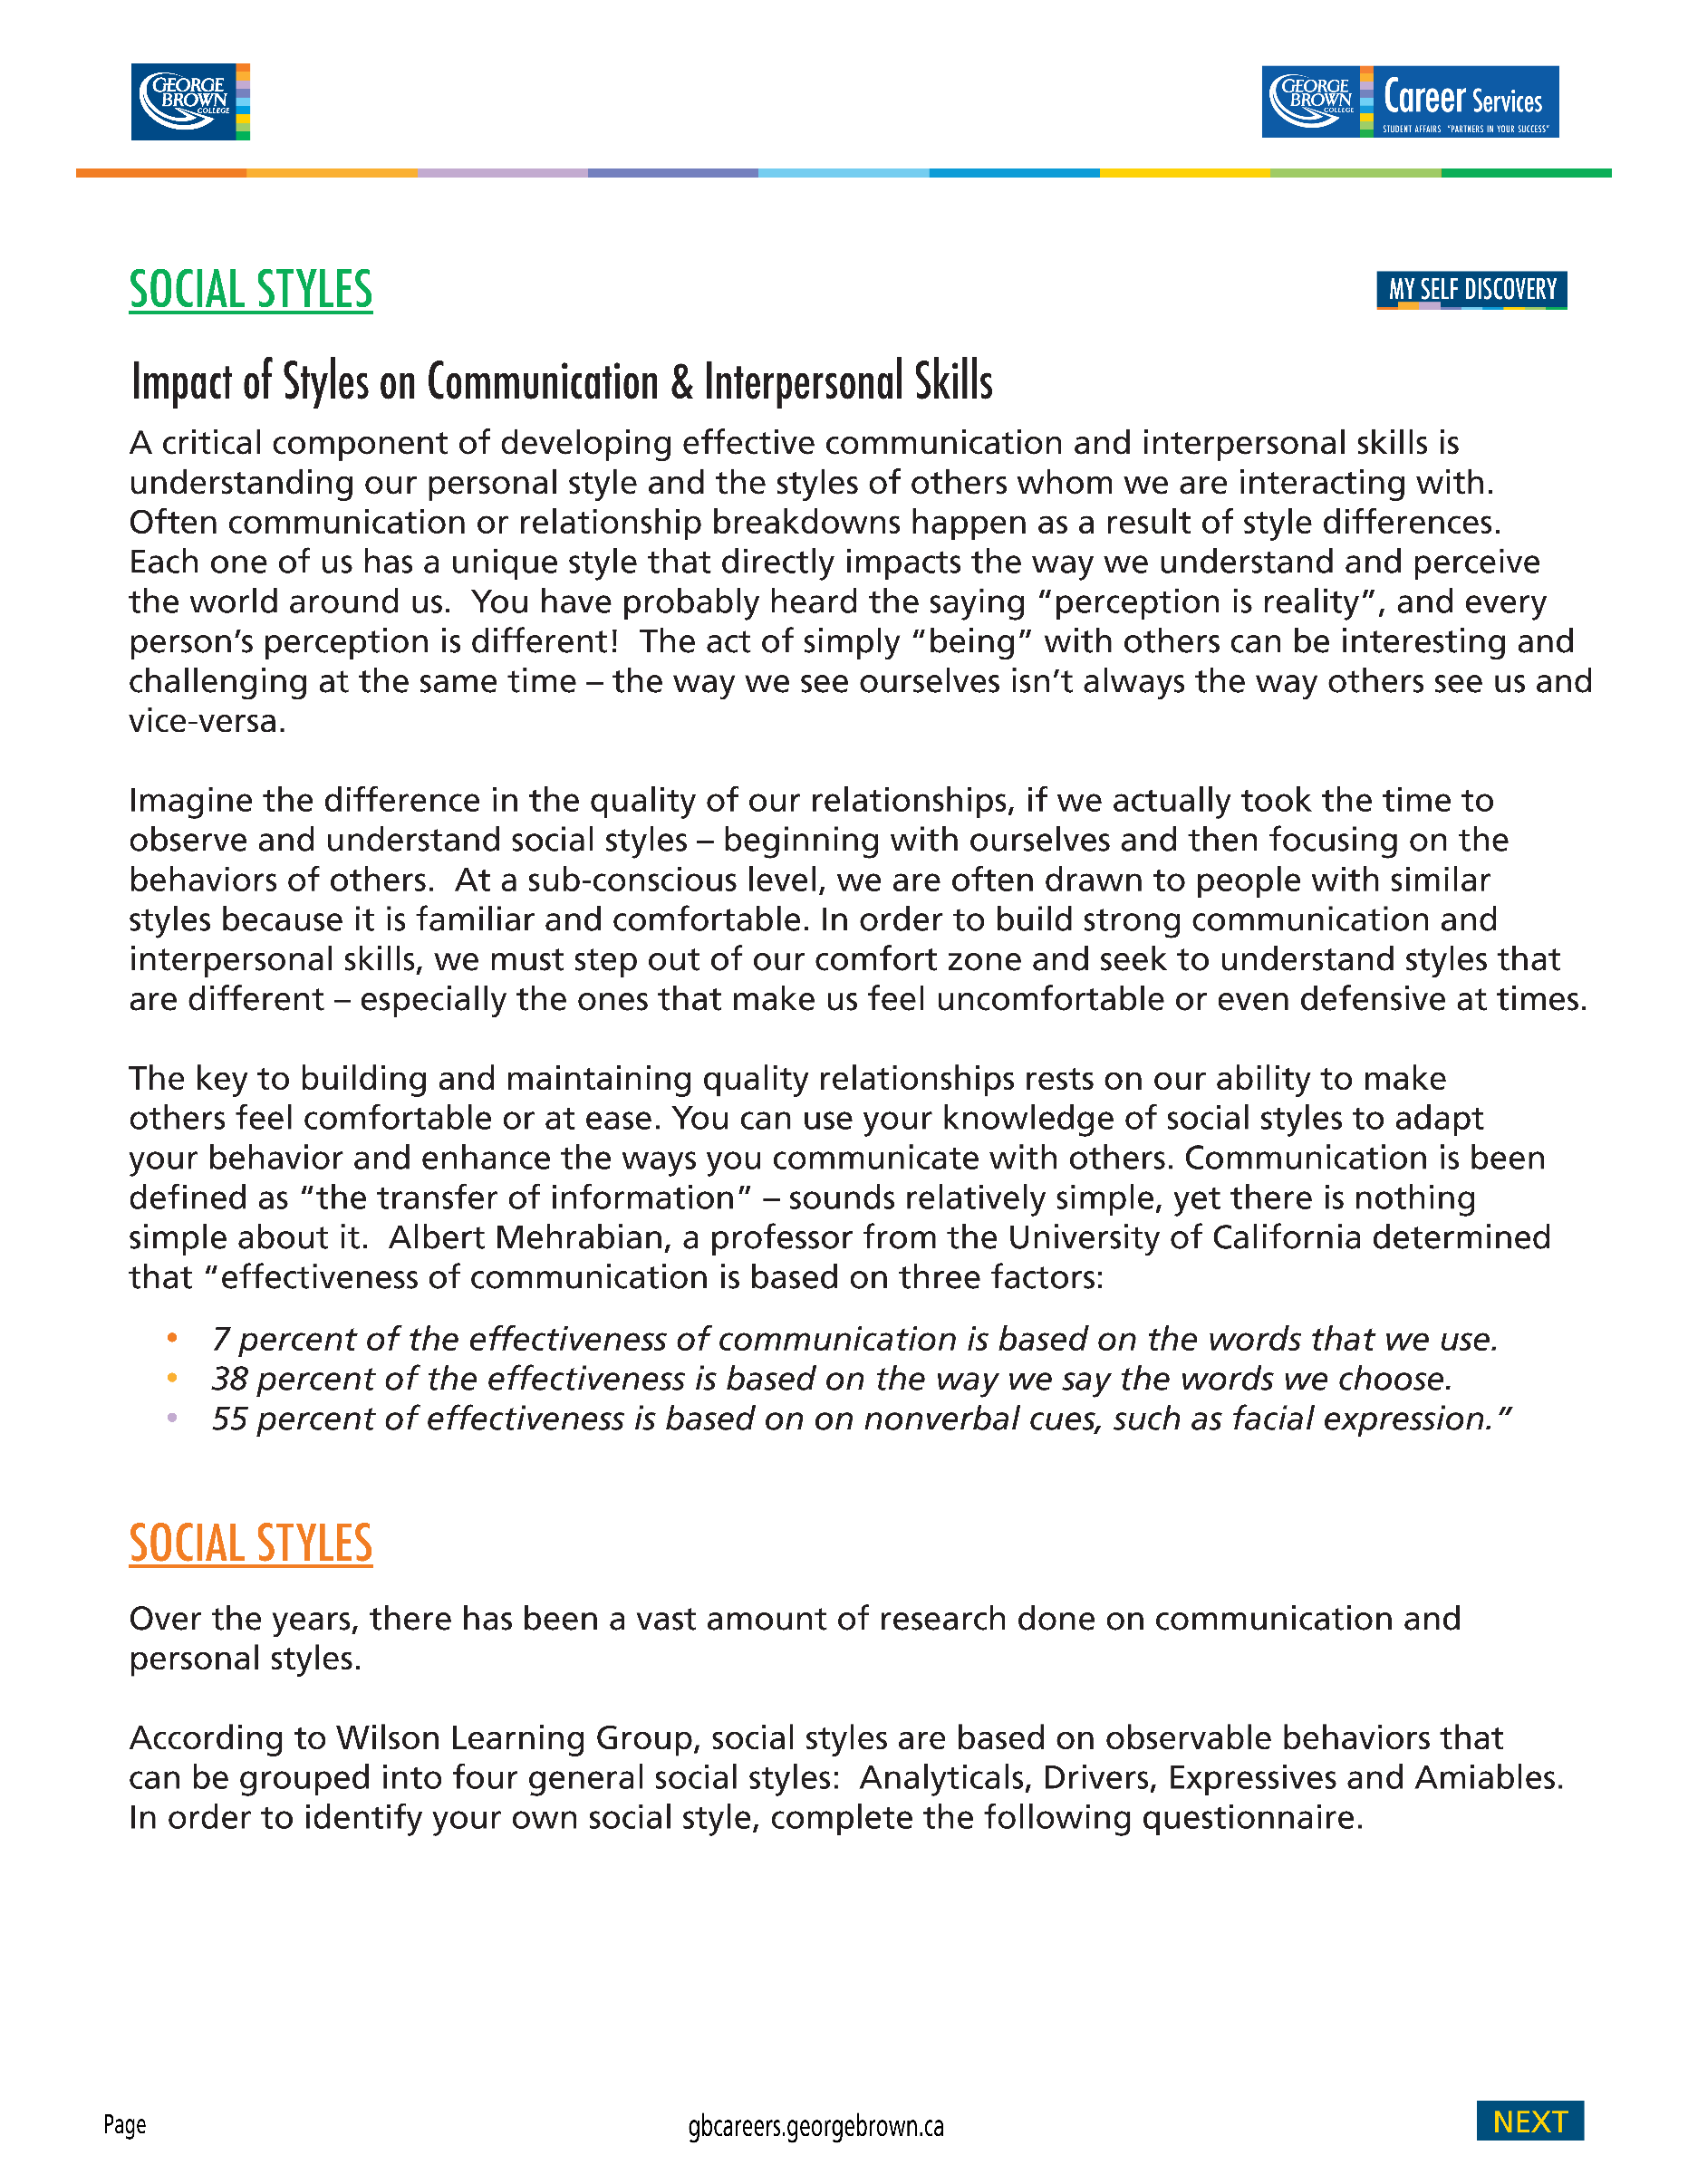

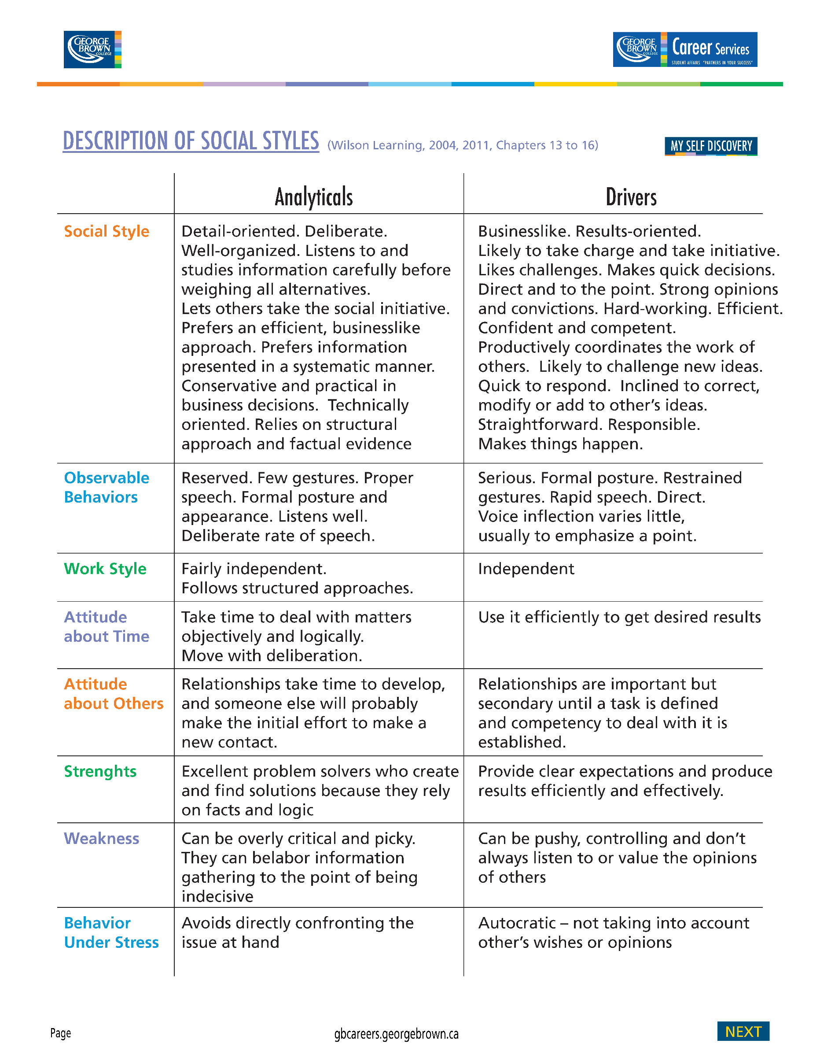

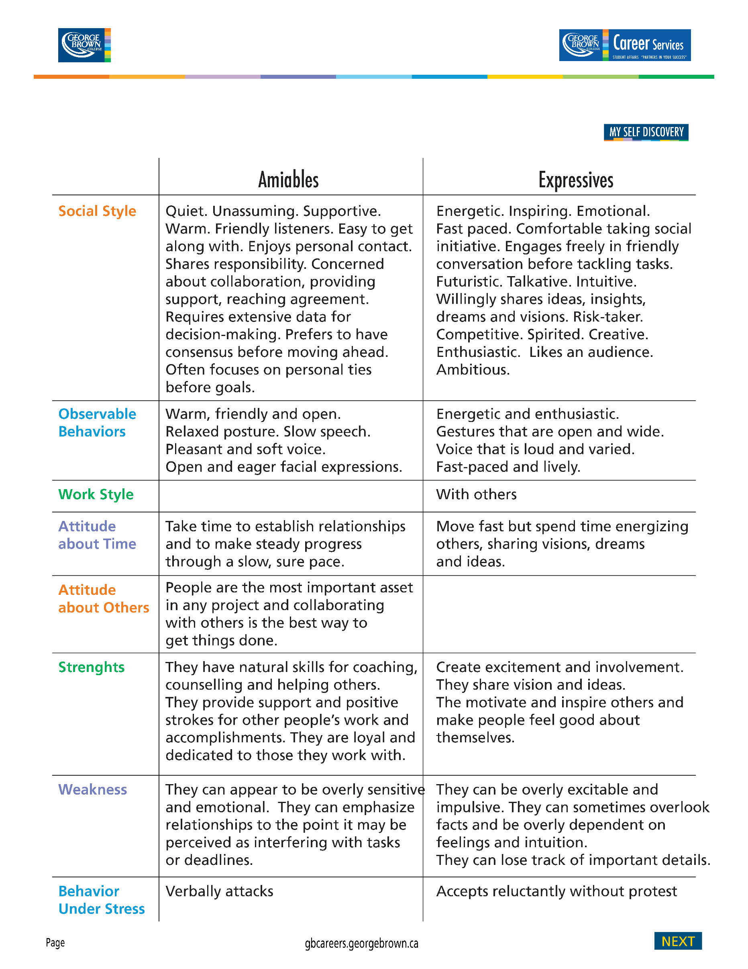

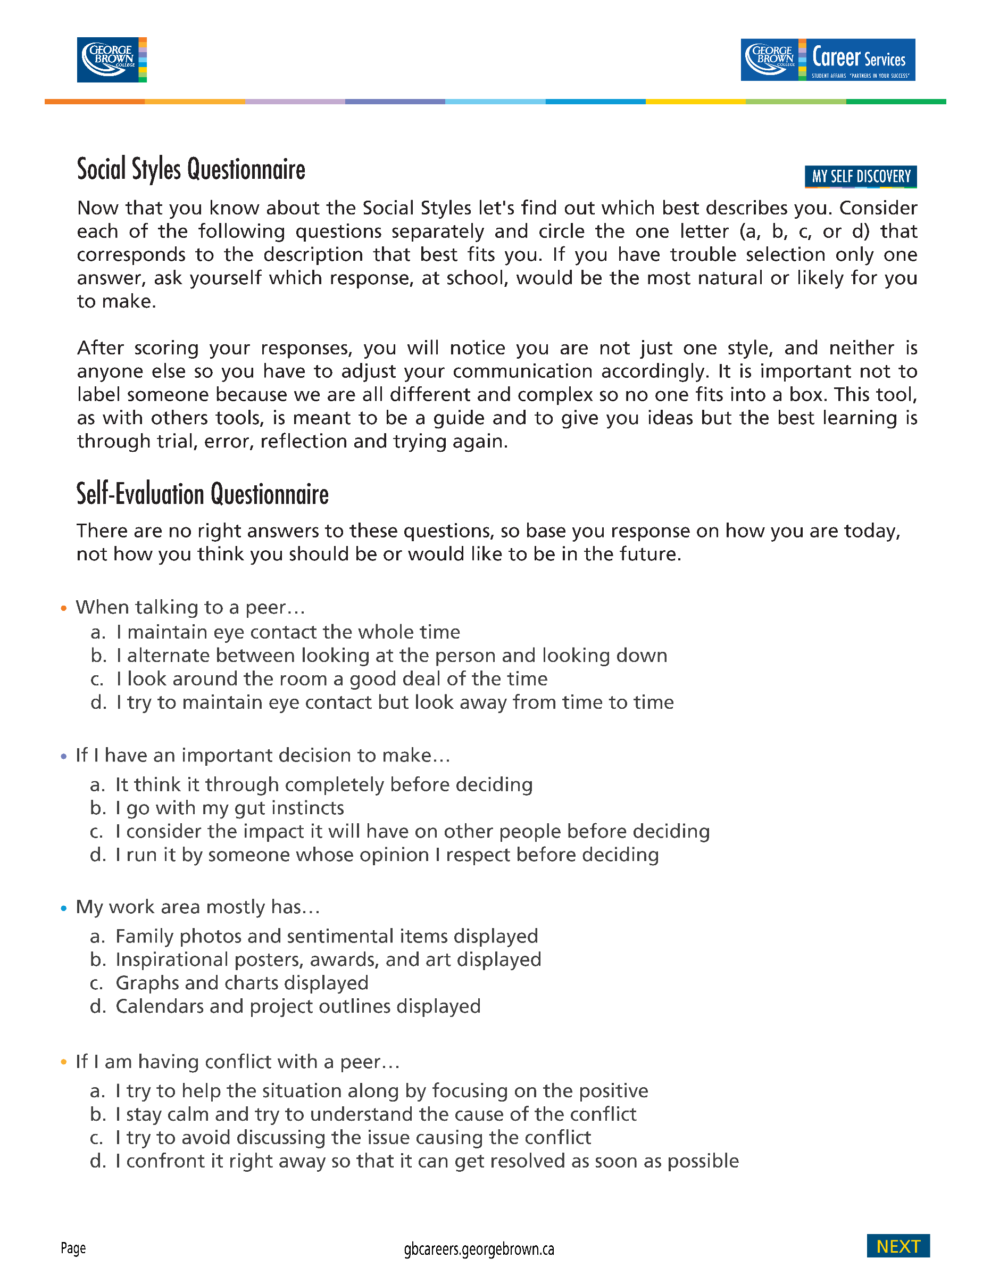

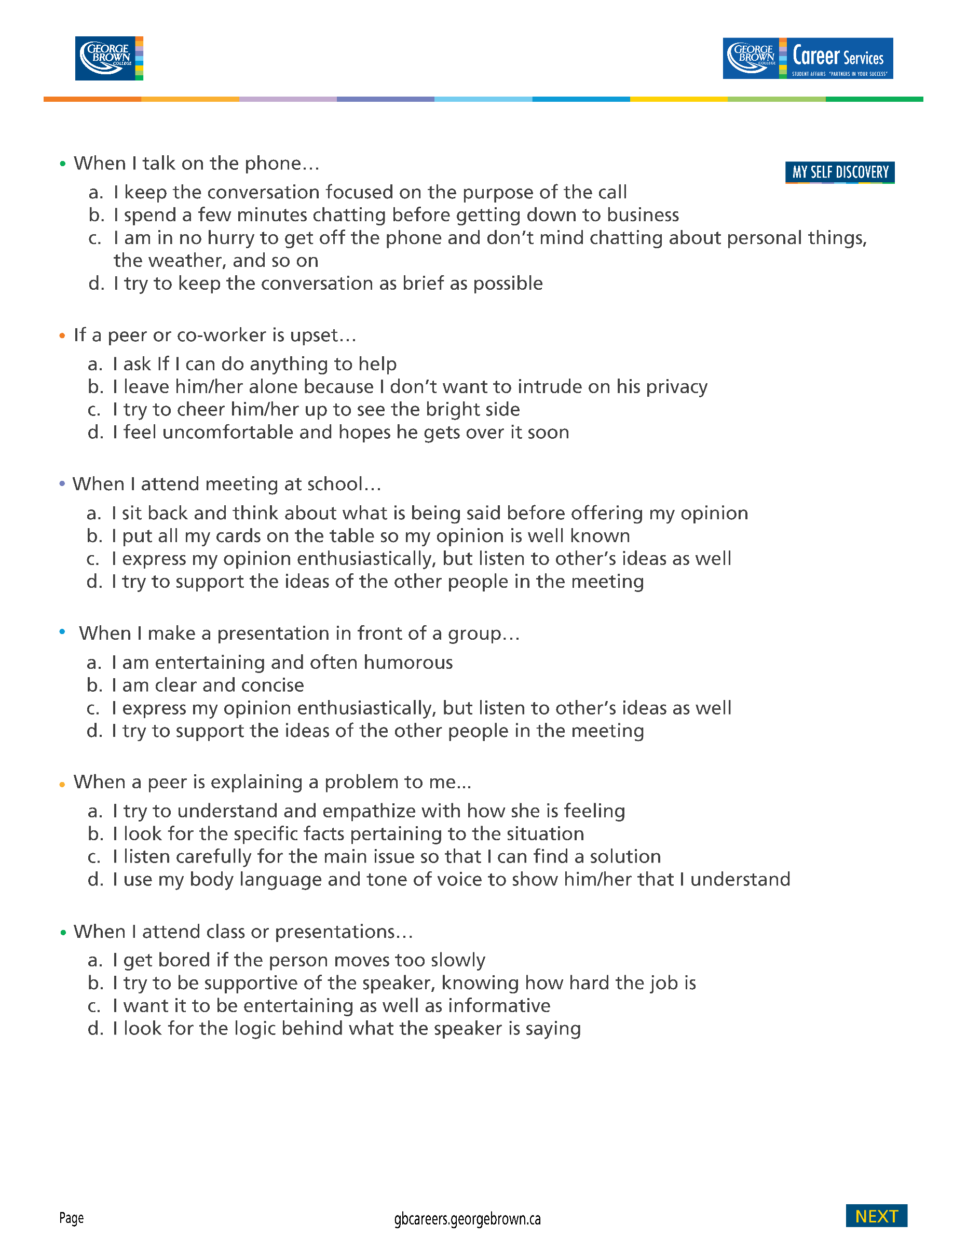

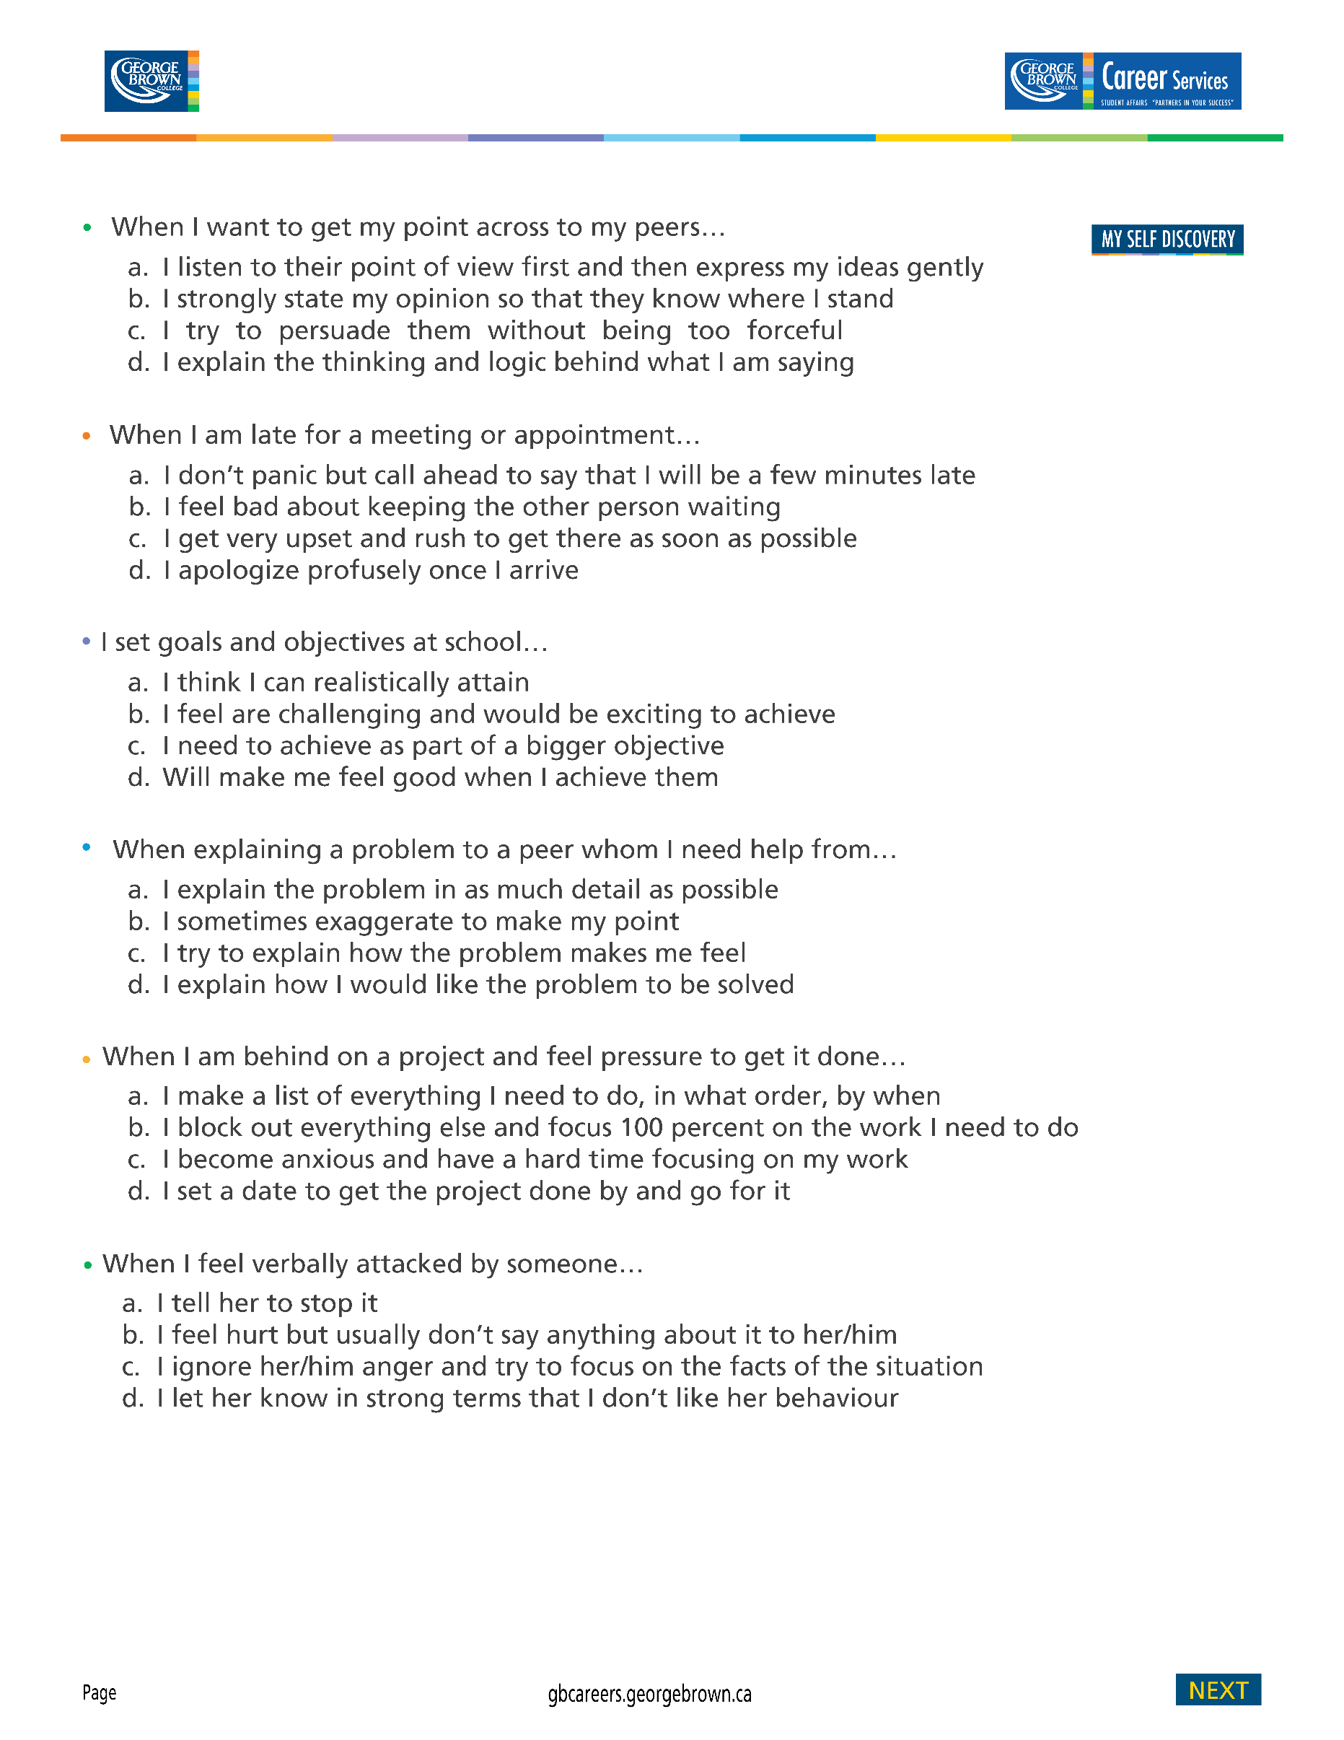

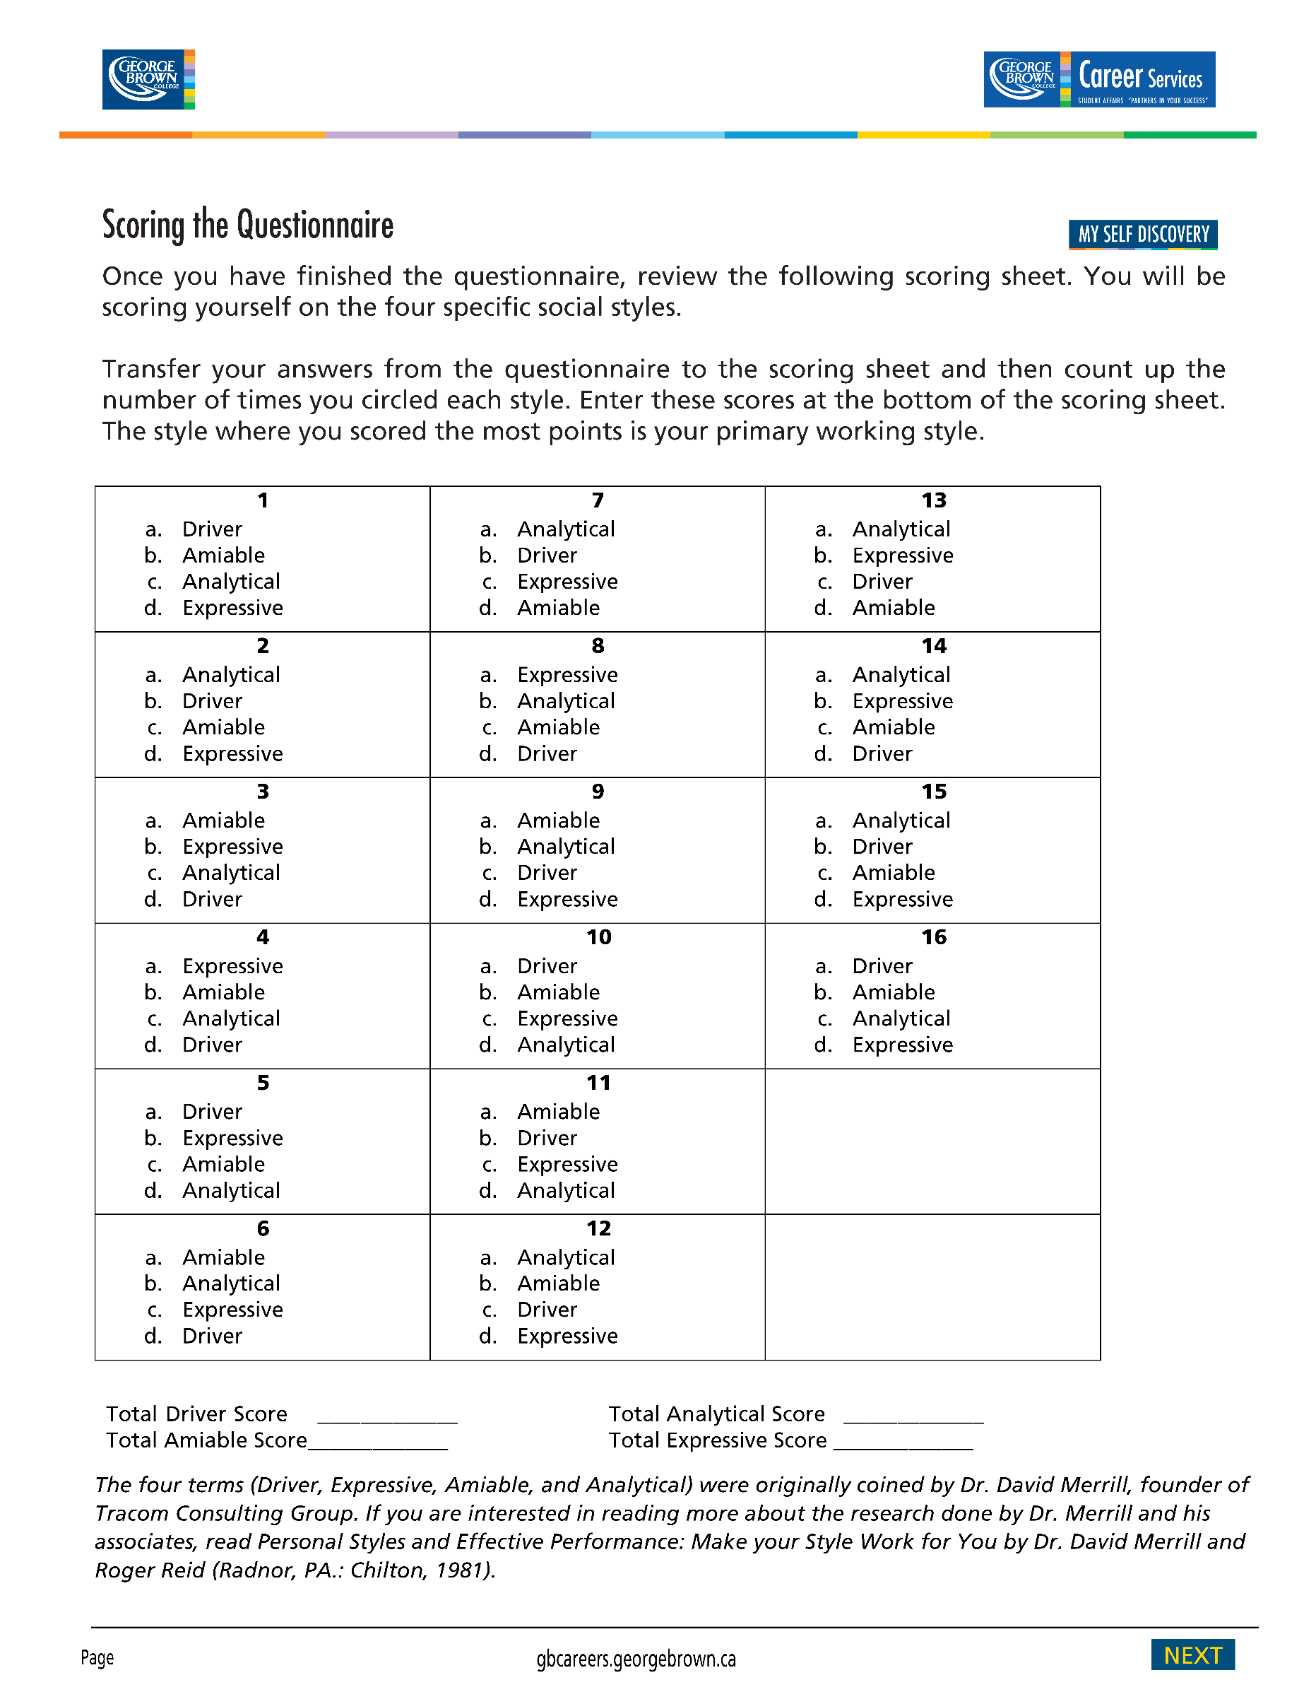

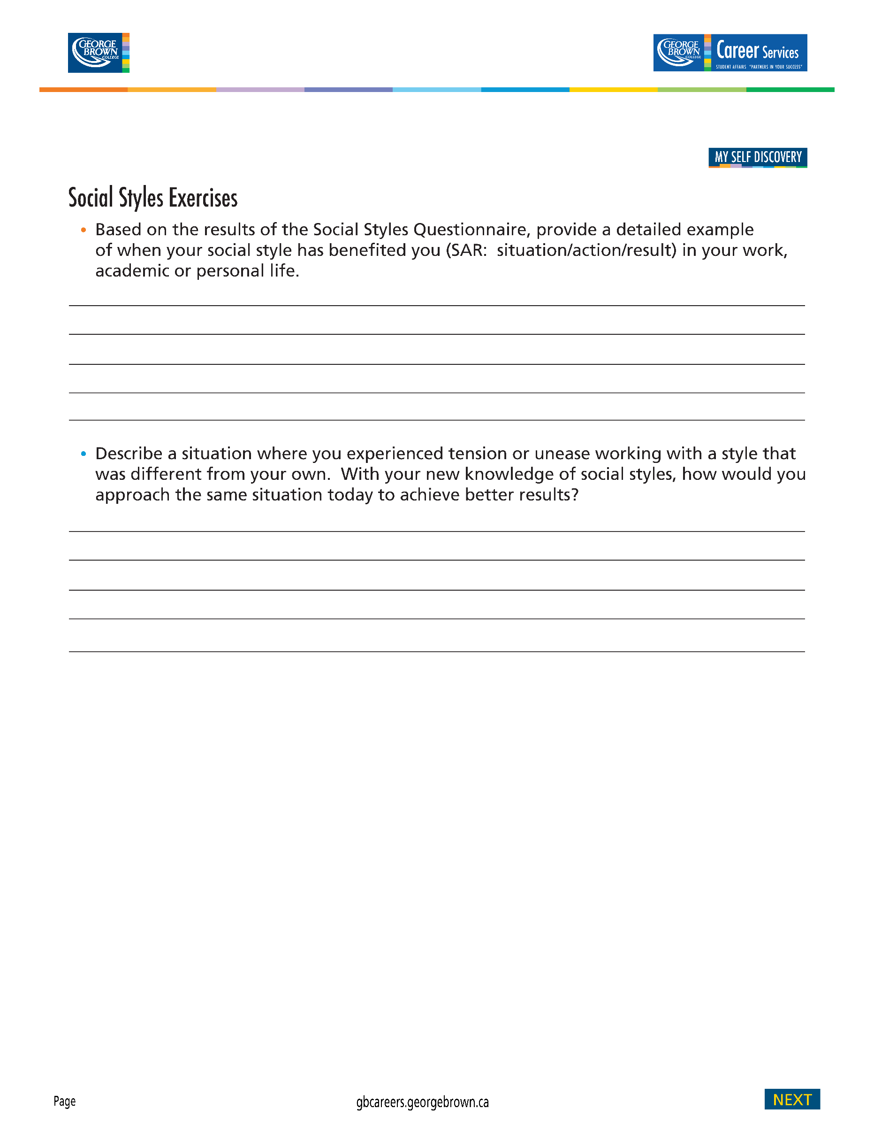

My Expressive Social Style has benefited me greatly in my career. In is one thing to come up with new ideas and it is another thing to be able to sell it to the powers that be. I am able to influence decision making by getting people excited and involved in my ideas. An example of this was rebranding the PAL Centres to Peerconnect. I had a vision of what I wanted to see and had to convince senior management of the benefits of going in this new direction. In my presentation, I had to create energy and enthusiasm about what the future of peer-to-peer programming could be and that GBC would be a leader in developing innovative programming that was not being offered at other post-secondary institutions. In the end, my proposal was approved and we had funds to rollout the program.



In meetings, an Expressive Style can easily dominate the conversation because we are loud, energetic and love to talk! In one particular meeting, I was going on about an idea and someone tried to interject into the conversation and I cut them off. The individual mumbled under her breath “it would be nice if other people could speak!” I just about died with embarrassment. I had no idea that people saw me as dominating when my intention was quite different. I apologized to my colleague after the meeting and realized that our strengths can have a “shadow” side if we are not using them appropriately. This is why reading a group’s body language is so important. I went to the next meeting with the intention to watch and listen more. I observed that my colleagues were a combination of analytical and amiable styles. To create positive tension with the two styles, I began speaking less and when I did speak I was concise and to the point. I began to ask others what they were feeling and encouraging them to put their ideas forward. I found that my new approach made me more effective in the meetings because it forced me to slow down and really listen to others. I also found that when I did speak, people were now really listening to me instead of silently shutting down and thinking “here she goes again!”

